PATNA WOMEN’S COLLEGe

(AUTONOMOUS)

PATNA UNIVERSITY

**NAAC Re-Accredited ‘A’ Grade with CGPA 3.58/4**

**“College with Potential for Excellence” (CGPA) status accorded by UGC**



**Department: - Master of Computer Application**

**Course: - M.C.A. Sem-6**

**Session: - 2016-2019**



**INTRANET MAIL SYSTEM**

**Submitted By: - Guided By: -**

**NAME:-PUJA KUMARI MANISH BHATIA**

**ROLL NO:-27**

**TITLLE OF THE PROJECT**

**INTRANET**

**MAIL**

**SYSTEM**

**TO WHOM IT MY CONCERN**

This is to certify that the project report entitled **“intranet mail system”** submitted to **PATNA** **WOMEN’S COLLEGE**, (**Patna University**) in partial fulfillment of the requirement for the award of the degree of MASTER OF COMPUTER APPLICATION (MCA), is an authentic and original work carried out by **MR. Manish Bhatia** with **roll no-27** under my guidance.

…………………......... MANISH BHATIA

(Project Guide)

**CERTIFICATE OF APPROVAL**

This is to certify that this project entitled “**INTRANET MAIL SYSTEM”** developed by **“ puja kumari”** of department of Master of Computer Application(MCA), session 2016-2019 of **PATNA WOMEN’S COLLEGE** is worthy of consideration for the partial fulfillment of the requirement for the award of degree in Master of Computer Application from patna university.

……………………….. ………………………….

**INTERNAL EXAMINER EXTERNAL EXAMINER**

…………………………….

**HEAD OF DEPARTMENT**

**Acknowledgement**

I would like to express my thanks of gratitude to our Principal “**Dr. Sister M. Rashmi A.C**” and our professors who gave me this golden opportunity to do this wonderful project on the topic “**INTRANET MAIL SYSTEM”,** Also we are grateful to our Head of Department professor “**Dr. Bhawna Sinha**” for her support.

We would like to thank our project guide “**Manish Bhatia”**. His genuine moral support has helped a lot to boost up our confidence level.

I hope that the mail rules of the intranet mail system will provide better understanding of the system to its users.

**THANKS AGAIN TO ALL WHO HELPED ME.**

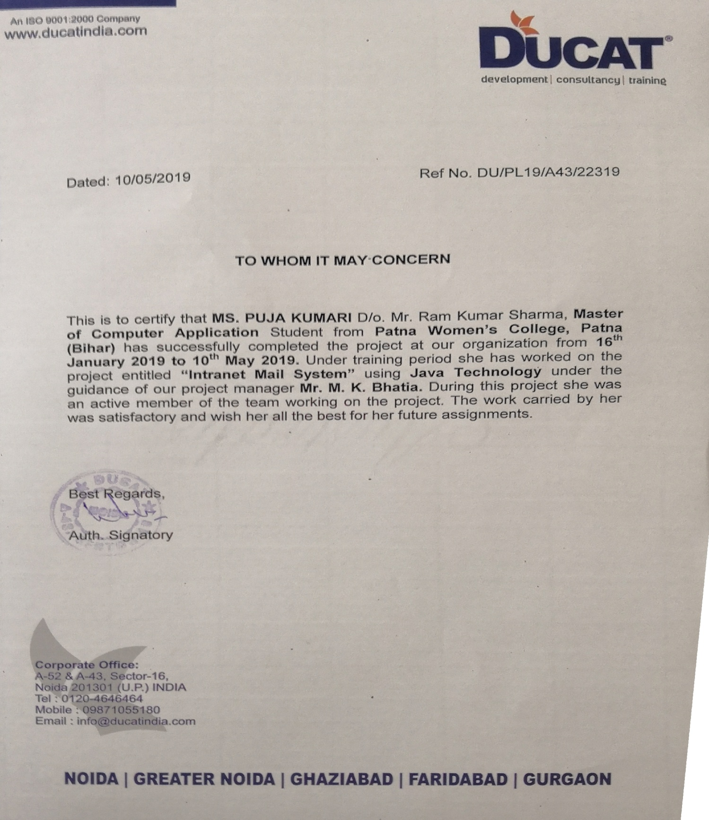

COMPANY PROFILE



* **Mentors play an essential role in an institute, the level of education, development of**

**Student’s Skills are based on their trainers.**

* **Ducat provides the best available programs which helps in enhancing the technical skills which seems to be beneficial for all the applicants.**
* **Software Development: We provide the best and latest IT software training which helps all the fresher and the corporate to understand well and give them the knowledge to go hand in hand with the latest technologies. This does not only helps the companies but also increases the self-level to deal with all the necessary software.**
* **Instructor led campus: Ducat helps all the new instructors to get the best exposure to show their talent in right way.**
* **Workshops and Placement Service: At Ducat, workshops are held to increase the understanding level because theoretical values are always not enough and workshops helps in getting the practical knowledge which results in better understanding. As everything leads to the placement because if the institute does not provide placement services then it is ultimately bad for the applicants but we provide the best placement services and for that we give our best to give you the best.**

**TABLE OF CONTENTS:-**

|  |  |  |
| --- | --- | --- |
| **S.N** | **TITLE** |  |

1. **Introduction**
   1. About The Project
2. **Objectives**
3. **System Analysis**
   * + 1. 3.1 Identification of need
       2. 3.2 Preliminary Investigation
       3. 3.3 Proposed System
       4. 3.4 Feasibility Study

3.4.1 Technical Feasibility

* + - 1. 3.4.2 Economic Feasibility
      2. 3.4.3 Behavioral Feasibility
      3. 3.5 Project planning
      4. 3.6 Project Scheduling
      5. 3.7 Software Requirement Specification(SRS)
    1. 3.8 Software Engineering and Paradism applied
    2. 3.9 Control flow diagrams, ERD, UseCase diagrams
    3. 3.10 Descriptions of tools used

1. **System design**

4.1 Modularization details

4.2 Data integrity and constraints

4.3 Database Design

4.4 User Interface Design

1. **Coding**
   * + 1. 5.1 Complete codding
          1. 5.2 Comment and descriptions
          2. 5.3 Standardizations of coding
          3. 5.4 Error handling
          4. 5.5. Validation check
          5. 5.6. Naming Convention
2. **Testing Introduction**

6.1. Test Plans

6.1.1 Unit Testing

6.1.2 Integration Testing

6.1.3 Validation Testing or System Testing

6.1.4 Output Testing or User Acceptance Testing  
 6.1.5 Debugging and code improvement

1. **System Security measures**
   * 1. 7.1 Database/data security

7.2 Creation of user profiles and access rigths

1. **Screen Shots**
2. **Report/Conclusion**
3. **Future scope and future enhancement of the project**
4. **Bibliography**
5. **Appendices**
6. **Glossary**

**Acknowledgement**

I would like to express my thanks of gratitude to our Principal “**Dr. Sister M. Rashmi A.C**” and our professors who gave me this golden opportunity to do this wonderful project on the topic “**INTRANET MAIL SYSTEM”,** Also we are grateful to our Head of Department professor “**Dr. Bhawna Sinha**” for her support.

We would like to thank our project guide “**Manish Bhatia”**. His genuine moral support has helped a lot to boost up our confidence level.

I hope that the mail rules of the intranet mail system will provide better understanding of the system to its users.

**THANKS AGAIN TO ALL WHO HELPED ME**

**1.INTRODUCTION**

* A company has different departments situated in different locations. One has four office and three sites (factory). These are situated at different places and have a minimum distance of 15 km.
* The basic problem is that they communicate or make correspondence only through post as their units are located in remote areas. This method of communication is very slow in nature and it’s not reliable.
* Therefore, the solution for this problem is to develop a communication channel that meet the need of the organization. Basically, the computerized solution is for improving the services as well as self-efficiency of the computer.
* This project “Intra Mailing System” aims at providing a good communication interface for the organization. It can cut down the time of employees send on routine communication tasks. Its successful Implementation makes easy the job of employees in the organization.
* This application provides facilities like mails, instant message and allows employees to communicate more effectively, and access the resources they need to maximize their day-to-day productivity. It provides fast and better access to up-to-date information.

**MAIL:**

Intra Mailing system allows organizations with intranet to exchange emails internally without the need of an Internet connection, in which

* Usually text is transmitted,
* Operations include sending, storing, processing, and receiving information,
* Users are allowed to communicate under specified conditions, and Messages are held in storage until called for by addressee.
* “Intra Mailing System” is the system which is used to establish online communication among the employees of an organization at different branches and within the organization between the departments. The employees of the organization can send mails to each other in different departments at different locations.
* The purpose of “Intra Mailing System” is, an employee of a company can send and receive mails only in that organization’s Local Area Network or Wide Area Network. It will work like Internet mailing System for this Intranet.

**Intranet mail system**

### Overview

This project synopsis documents the process of the “Intranet Mailing System” has been developed out of a need for communation between the Employees of the organization and their colluges. “Intranet Mail System” provides a means by which employees can place their queries and message, reply to each others quires, send each others mails and basically keep in touch across the network.

This document is an overall description of the requirement for an “Intranet Mail System” to be implemented in an organization.

This “Intranet Mail System” will fulfill all tha organizational needs of the employees as well as the clients in a user friendly and an efficient manner overcoming the shortcomings of the current manual system to a major extent.

This would be a web based application that would provide a single platform for all the employees or users of an organization sitting at different locations to interact with each oter and make a community for messaging, blogs, forums, reports and query. It helps in making the communication faster and easier.

It will manage all the departments, roles, employees and all the queries of the users.

The different employees of the organizations can easily send messages to each other and intract. They even upload their daily activity reports, weekly activity reports and monthly activity reports.

All the management is done by administrator and get the solution. Various reports can be generated by the administrator and the users.

* 1. **Exiting Problems**

The manual work and messge which is nesaccery to convey to from one user to other can be manage easily and rapidly.

Like:

* Sending some information via mail.
* Communication of the user is now easy by using chat in the network.
* Sending attachment of file via mail

All these work can be done rapidly and very easily.

**2.OBJECTIVES**

One of the objectives behind developing this software(Intranat Mail System) is to fulfill all the communication needs of the employees as well as the clients in an organization in a user friendly and efficient manner.

This would be a web-based application which provides a single platform for all the employees or users of an organization sitting at different locations to intranet with each other and make a community for messaging, blogs, forums & reports and query. It helps in making the communication easy and faster.

Another objective is to manage all the departments, roles, employees and all the queries of the user. Here different employees of the organization can easily send messages to each other and interact. They can even upload their daily activity reports, weekly activity reports and monthly activity reports.

**3. SYSTEM ANALYSIS**

The word “SYSTEM” covers a very broad spectrum of concepts. This is derived from a Greek word *“systema”,* which means an organized relationship among the functioning units or components.

System analysis, then, is the process of gathering and interpreting facts, diagnosing problems and using the information to recommend improvements to the system. In brief we can say that analysis specifies what the system should do. Design states how to accomplish the objective.

System analysis is concerned with becoming aware of the problem, identifying the relevant and decisional variables. Analyzing and synthesizing the various factors and determining an optimal or at least a satisfactory solution or program of action.

A detailed study of the process must be made by various techniques like interviews, questionaries etc. The data collected by these sources must be scrutinized to arrive to a conclusion. The conclusion is an understanding of how the system functions. This system is called existing system. Now the existing system is subjected to close study and problem areas are identified. The designer now functions as a problem solver and tries to sort out the difficulties that the enterprise faces. The solutions are given as proposals. The proposal is then weighed with the existing system analytically and the best one is selected. The proposal is presented to the user for an endorsement by the user. The proposal is reviewed on user request and suitable changes are made. This is loop that ends as soon as the user is satisfied with proposal.

System analysis plays a major role in software development process. A sound analysis leads to the development of a sound system. A good analysis gives the base for a good designing.

I conducted the system analysis for my system. Here the motive is to gather the information about the current system and to find whether or not the proposal is feasible. For this purpose I did the following studies:

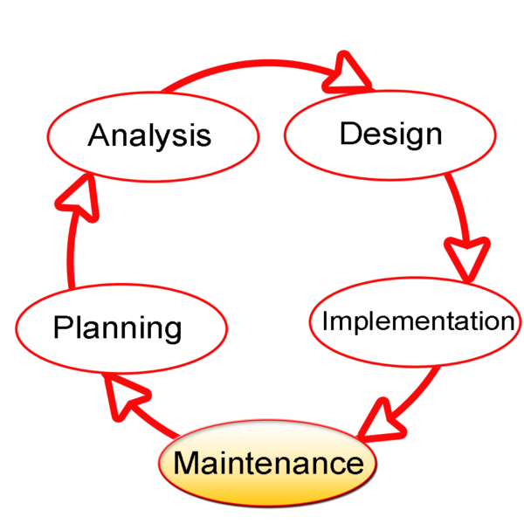

**3.1. IDENTIFICATION OF NEED**

The most important tasks of system analysis are to identify the problem because without having an idea of problem it is impossible to specify the requirement for a new project with any accuracy Here we try to answer the questions:

Q. What the user is looking for, in the current system?

Q. What are the problems they are facing in the current system, if any?

Q. What is the intensity of these problems on the current system?

The answers of these questions leads me to the identification of user need.

I identified the following user’s needs in the current system:

* Users need a system by which they can communicate with the other user.
* They want to lessen the time to convey the message form one user to another.
* They the services of the sending email or message to the users in the networks.
* An intarnet based solution is accepted by everyone.
* User need a way by which they can got solulation rapidly my the mail and also can download the attachment of mail.

I analysed that all these needs of the users are being fulfilled by my system, so this system will be appropriate to introduce .

**3. 2. PRELIMINAR INVESTIGATION**

The purpose of preliminary investigation is to evaluate project requests. It is the process of collecting the information that help to evaluate the merit of the project request and make an informed judgment. Preliminary study is problem solveing activity that requires intensive communication between the system users and system developers.

In this phase I conducted the following investigations:

3.2.1. REVIEWING ORGANISATIONL DOCUMENTS:-

During this phase I observed the various documents of the “Intranet Mail System”.I reviewed the following documents:

* Communicaton report
* Activities of users report
* Download Mail to get Information
* Send Infromation to the user schedule by Admin

3.2.2. ON SITE OBSERVATION:-

On site observation is another important technique to collect data. In this phase I observed the activities of the Intranet Mail system going on the site. There I observed the following functionalities:

1. First the user mail the information to the other user in the network
2. Either he searches on his own or ask for any to the employee.
3. The employee searches the required information.
4. Now the Infromation is got from the other user.
5. The uer go forward by using information.
6. Again the uers can send query to the antoher user to process his work.

3.2.3 INTERVIEWING:-

I conducted the preliminary interview with the owner, employees and customers of the store.

1. Interview with the owner: I asked following set of questions to the owner of the store.

Q. Who are involved in the whole system and what are their roles?

Q. How efficient the current system is?

Q. Are there any loopholes in the current system?

Q. How much cost can you bear?

Q. Your reaction towards making the system in intranet network?

b) Interview with the employees: I also interviewed the employees and presented the following set of questions.

Q. How much are you satisfy from the current system?

Q. How will you rate its efficiency?

Q. How much time the search operation consumes?

Q. What happens if the search is based on advance keywords?

Q. How much helpful computers are in your daily work?

Q. Your reaction towards making the system in Intranet network?

**3.3 PROPOSED SYSTEM**

The aim of proposed system is to develop a system of improved facilities. The proposed system can overcome all the limitations of the existing system. The system provides proper security and reduces the manual work. The existing system has several disadvantages and many more difficulties to work well. The proposed system tries to eliminate or reduce these difficulties up to some extent. The proposed system will help the user to reduce the workload and mental conflict. The proposed system helps the user to work user friendly and he can easily do his jobs without time lagging.

**Expected Advantages fo proposed Sytem**

The system is very simple in design and to implement. The system requires very low system resoureces and the system will work in almost all configurations. It has got following features:

* + - * + Ensure data accuracy’s.
        + Proper contral of the higher officials.
        + Reduce the damages of the machines.
        + Minimize manual data entry.
        + Minimum time needed for the various processing.
        + Greater efficiency.
        + Better service.
        + User friendliness and interactive.
        + Minimum time required.

**3.4 FEASIBILITY STUDY**

Feasibility is the determination of whether or not a project is worth doing. This type of study determines if a project can and should be taken. A feasibility study is carried out to select the best system that meets performance requirements.

A feasibility study of a system proposal is according to its workability, which is the impact on the organization, ablity ot meet their user needs and effective use of resources. Thus when a new application is proposed it normally goes through a feasibility study before it is approved for development.

The document provide the feasibility of the project that is being designed and lists various areas that were considered very carefully during the feasibility study of this project such as Technical, Econiomic and Operational feasibilitys.

To check whether the proposed system is worth making or not I conducted the feasibility study in which I studied the following aspects.

3.3.1. TECHNICAL FEASIBILTY:-

The system must be evaluated from the technical point of view first. The assessment of this feasibility must be based on an outline design of the sytem requirement in the terms of input, outout, program and procedure. Having identified an outline system, the investigation must go to suggest the type of equipment, required method developing the sytem, of running the system once it has been designed.

Technical issues raised during the investigation are:

* Does the existing technology sufficient for the suggested one?
* Can the sytem expand if developed?

The project should be developed such that the necessary functions and performance are achieved within the constraints. The project is developed within latest technology. Through the technology may become obsolete ofter some period of time, due to the fact that newer version of same software supports older versions, the system may still be used. So there are minimal constraints involved with this project. The system has been developed using java the project is technically feasible for development.

Here we are concerned with specifying the equipments and software that will successfully satisfy the requirements of the system. While studying the technical feasibility I observed the following aspects:

* There is adequate and regular power supply.
* There is easy availability of intranet network and also client of the system can avail the connection with minimum cost.
* Specified H/W like processor of about 1GHz with a 256MB RAM and

S/W like JAVA and MySql are already available with the client.

**Tools Used*:*** 1)J2EE Library

2)J2SDK 6.0

3)JDK 1.6

4)weblogic sever

5)MySql

After observing the above said aspects I can say that this system is technically feasible.

3.3.2. OPERATIONAL FEASIBILTY:-

Here we consider the human aspect of the organization. This test of feasibility asks if the system will work when it is developed and installed. In this stage I observed the aspects.

* Everyone welcomes the new system and there was hardly any resistance because of ease of access and user friendly environment.
* The existing staff is skilled enough and is computer literate to handle the new system.
* It was perceived that the system, when launched, will do no harm to the existing business.

After observing the above aspects it was concluded that the system is operationally feasible.

3.3.3. ECONOMICAL FEASIBILTY:-

The developing system must be justified by cost and benefit. Criteria to ensure that effort is concertrated on project, which will give best, return at the earliest. One of the factors, which affect the development of a new system, is the cost it would require.

Here we are concerned with the economical aspect of overall system. A system that can be developed technically and that will be used if installed, must still be profitable for the organization. Here I estimated the following costs:

* One time development cost
* One time H/W and S/W cost
* Periodic maintenance cost

After analysis it was found that this cost was less than the current system cost.

It also provides the following features:

* Ease of access
* Fast processing
* Fast retrieval of information

After these studies it was concluded that this system is economically feasible.

**3.5 PROJECT PLANING**

Software project management begins with a set of activities that are collectively called project planning. The objective of software project planning is to provide a framework that enables the manager to make reasonable estimates of resources, cost, and schedule. These estimates are made within a limited time frame at the beginning of a software project and should be updated regularly as the project progresses. Here I have prepared the PERT chart for planning.

3.4.1. COST ESTIMATION:-

In this activity, the cost of the project is estimated. This includes money effort, resources and time to build the software. It is done before creating the software. It is the step of software project planning.

Estimation begins with a description of the scope of the project. Until the scope is bounded, it’s not possible to develop the meaningful estimate. The problem is then decomposed into a set of smaller problems and each of these is estimated using historical data and experience as guides. Estimation carries inherent risk and this risk leads to uncertainty.

There are three factors, which affect the uncertainty inherent in planning factors. These are: -

* Project complexity
* Project size
* Degree of structural uncertainty
* Availability of historical information

The estimation can be done based on object point, function point or the lines of code. I have done this estimation based on object points of the software. “Boehm”, which is constant gives weights on the object. Taking these constants, we can easily estimate the cost of the software.

**3.6 PROJECT SCHEDULING**

3.6.1 Pert Chart:-

A PERT (Program Evaluation and Review Technology) chart is a network of boxes (or circles) and arrows. There are different variations of PERT Charts, some use the boxes to represent the activities and some use arrows to do so.

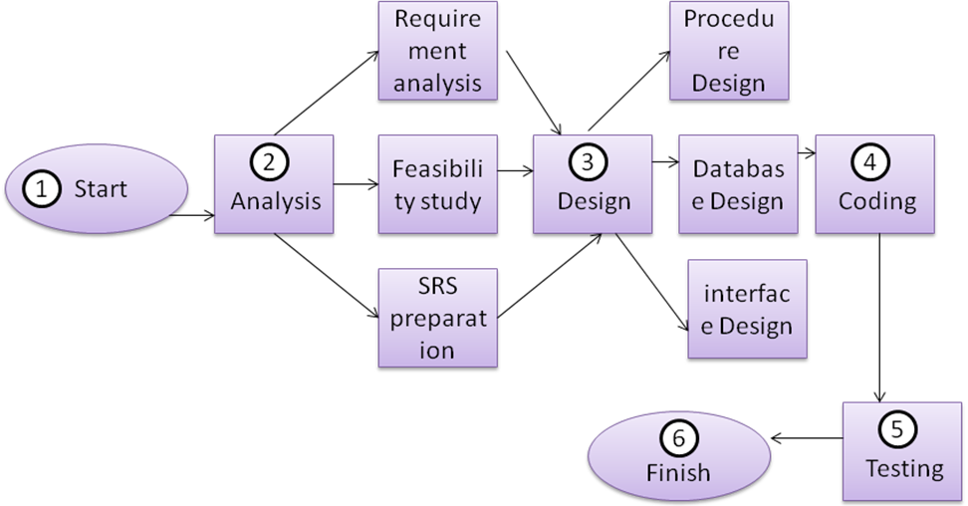

3.6.2 Gannt Chart

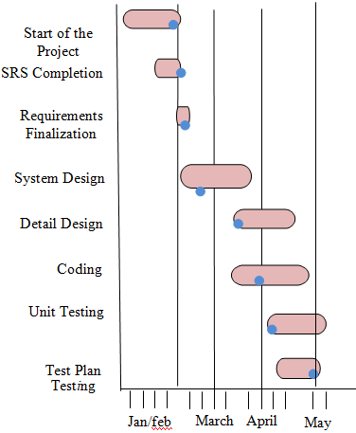

**3.7 SOFTWARE REQUIREMENT SPECITION (SRS)**

1. INTRODUCTION:-

* 1. PURPOSE:- The purpose behind developing this software(Intranat Mail System) is to fulfill all the communication needs of the employees as well as the clients in an organization in a user friendly and efficient manner.

This would be a web-based application which provides a single platform for all the employees or users of an organization sitting at different locations to intranet with each other and make a community for messaging, blogs, forums & reports and query. It helps in making the communication easy and faster.

* 1. SCOPE:- Following are the features which are in the scope of the software:
* Managing the Mail of the users.
* Providing facilities for sending mail and chating with other user in the network.
* Providing feature to download the mail attchment.
* Provide the information like mail from admin, chart toppers etc.
* Provides user authentication.
* Fecility of downloadin to maintain the status.

1.3 REFRENCEs:- Not applicable.

1.4 OVERVIEw:- The rest of the SRS is organized as follows:

* Section two projects the overall description of the software. It tells about the product and its functioning. It also gives information of who will be the users of the system.
* Section three elaborates the specific requirements of the software. It includes interface requirements, hardware and software requirements along with other requirements.

2. OVERALL DESCRIPTION:-

This would be a web based application that would provide a single platform for all the employees or users of an organization sitting at different locations to interact with each other and make a community for messaging, blogs, forums and reports and query. It helps in making the communication faster and easier.

It will manage all the departments, roles, employess and all the queries of the users.

The different employees of the organizations can easily send messages to each other and interact. They can even upload their daily activity reports, weekly activity reports and monthly activity reports.

All the management is done by the administrator. The employees can send their queires to the administrator and get the solution. Various reports can be generated by the administrator and the users.

3. SPECIFIC REQUIREMENTS:-

3.1 FUCTIONAL REQUIREMENTs:- Functional requirement specifies which output should be produce from the given I inputs. They describe the relationship between the input and output of the system. Here I have discussed some use cases:

USE CASE 1: Login

Primary actor: user

Main scenario

1:Start the application, user prompted for login and password.

1. User provides login and password
2. System does authentication.
3. User home screen is displayed.

Alternate scenario

1. Authorization fails.
2. Prompt the user for re-type the login information.

USE CASE 2: Change password

Primary actor : user

Pre condition: User logged in

Main scenario:

1. User initiates the password change option.
2. User is prompted for old password, new password and confirm password.
3. User gives old password, new password and confirm password.
4. System does authorization.
5. New password is registered with the system.

Alternate scenario:

1. Authorization fails.
2. Prompted the user that he typed wrong password.
3. Allow him to re-enter the password.

3.2 PERFORMANCE CONSTRAINTS:-

* 90% of the responses should be within 2-5 seconds.
* Reports should be printed in less than a minute.

3.3 DESIGN CONSTRAINTS:-

3.3.1: Software Constraints: This system will run under the Windows operating system. It requires java , weblogic server, MySql, to run on.

3.3.2: Hardware Constraints: The system requires a Pentium processor of 1GHz or above and a RAM of minimum 256MB.

**3.8. SOFTWARE ENGINEERING PARADIGM APPLIED**

Software Engineering is a field which combines process, methods and tools to develop good quality software, operation and the maintenance of the software with systematic, disciplined, quantifiable ways. A process model or a software engineering paradigm is chosen based on the nature of the project and application, methods to be used, and the controls and deliverables that are required.

There are many models to develop the software. Such as, Build and Fix Model, Iterative Enhancement Model, Waterfall Model, Prototyping Model, Spiral Model, and RAD Approach. But the “Waterfall Model” has been chosen for the development of the “Intranet Mail Sytem” software. The underlying reason for choosing the “Waterfall Model” is that, each phase has well-defined starting and ending points, with clearly identifiable deliverables to the next phase.

In the “Waterfall Model”, each phase is completed before the start of a new phase. The waterfall model is the sequential model that suggests a systematic, sequential approach to system development that begins at the system level and progresses through analysis, design, coding, testing and maintenance. The software “Intranet Mail System” has followed all the phases which are in the “Waterfall Model” is as follows-

**Requirement Analysis**

The requirement gathering process is intensified and focused specifically before the development of the software. Before the development of the software “One Stop Parking”, all the requirements for both hardware and the software have been documented. Software likes, in which programming language the software is going to be developed? Is the programming language will be compatible with our existing hardware? As Java programming language has been chosen to develop the “One Stop Parking” software, so it needs 32-bit machine to run the software. What are the designing tools and languages as well as software are going to be used to develop the software? Which scripting language is going to be used? Are we using any IDE (Integrated Development Environment) or not? Is it Web based system or not? If the System is Web based, then we need the Internet also. The compulsory requirements of the input/output device have been managed, to run the “One Stop Parking” software. It also requires, modem, cables etc. to test the software, as it is Web based. At this phase, the user’s requirements are carried out a detailed study. After carried out the entire requirement and the visualizing the feasibility of the system, the proposed system to be built, has been arrived. The model of the system is used to freeze all requirements before the starting of the next phase.

**Design**

A set of graphical tools has been used to represent a logical system model to formalization the user with system characteristics and interrelationships before implementation the tools are – Data Flow Diagram (DFD) and Data Dictionary. The purpose of the design phase is to specify a particular software system that will meet the state requirements. “One Stop parking” software has been developed in two phases. In one phase, the complete structure of the project has been designed in block level and in second phase the block has been separated to perform the detailed design of each block. In this phase, various blocks of overall system, compact and workable modules in each block, data structures, specifying the details of the programs to achieve desired functionality, design of input and output forms, preparing documentation of the design, has been designed. The design phase completely and correctly describes the system. The design specifications that get generated at the end of this phase are technical in nature and contain user interfaces, databases and data structures. Software design is actually a multi step process that focuses on four distinct attributes of a program: data structure, software architecture, interface representations, and procedural (algorithmic) details. The design process translates requirements into a representation of the software that can be assessed for quality before coding begins.

**Coding**

The coding phase produces the actual code that may be delivered to the customer as the running System. The “One Stop Parking” software has been coded in “Java” programming language. All the best efforts have been put to develop the software. For the better readability and understandability of the code, the software has been modeled in small chunks and the best efforts have been put to maintain the standard of the software development. Some standards are, Name of the Module, Uniform appearance of the code etc. Individual modules developed in this phase have been tested before being delivered to the next phase.

**Testing**

Testing is the process of running the software on manually created inputs with the intention to find errors and bugs. All the modules that have been developed before are integrated or put together in this phase, and tested as a complete System. On the ending of the coding phase, the testing phase begins. In order, for the input/output accuracy of the software, various testing techniques have been applied. Some testing are, System testing, User Acceptance testing, integration testing etc. During testing, on the encounter of any error, immediately the code has been changed so that the desired input and output can be obtained. The testing process focuses on the logical internals of the software , ensuring that all statements have been tested , and on the functional externals; that is conducting tests to uncovers errors and ensure that defined input will produce actual results that agree with required results.

**Maintenance**

Once the software becomes operational, whatever changes are done is termed as maintenance. It is necessary to eliminate errors in the working system during the working life of the software and to tune the system to any variations in its working environment. The software “One Stop Parking” is maintained in this way that if the requirement increases; it (software) can be altered by anybody effortlessly. In order to the maintenance of the software, the lifecycle of the software has been loosely coupled and highly cohesion.

*Waterfall Model with Feedback*

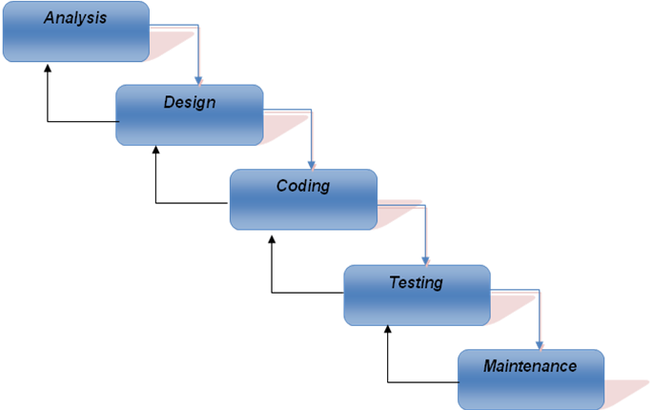

**3.9. ANALYSIS MODELS**

Over the past two decades, a large number of analysis modeling method have been developed. However all analysis methods are related by a set of operational principles:

* The information domain of a problem must be represented and understood.
* The function that the software is to perform must be defined.
* The behavior of the software must be represented.
* The analysis process should move from essential information toward implementation details.

Analysis modeling uses a combination of text and diagrammatic forms to depict requirement for data, function and behavior in a way that is relatively easy to understand and more important, straight forward to review for correctness, completeness and consistency. As per this system I conducted the following analysis:

3.7.1 CONTENT ANALYSIS:-

During content analysis we provide all the content of our application. These content includes text, graphics, and images, video and audio data. Here I analyzed that text graphics and images are the important aspects of my project, which plays important role for the identification of my application. For this purpose I have done Data modeling which is also the important part of this analysis and is used to describe and identify each of the data objects. For this purpose I made the ER-model to elaborate the concept.

3.7.2 FUNCTIONAL ANALYSIS: Here we are concerned with the transformation of information and its flow through the system. Here I have used Data Flow Diagram (DFD) to elaborate the functional modeling. DFD is a graphical representation that depicts information flow and the transforms that are applied as data move from input to output. Functional model perform three generic functions - Input, Processing, Output. The functional model begins with a single context level model. Over a series of iterations increasingly functional details are represented until through system functionality is appears.

DATA FLOW DIAGRAM:-

The Data flow Diagram shows the flow of data. It is generally made of symbols given below:

(1) A **square** shows the Entity: -

(2) A **Circle** shows the Process: -

(3) An **open Ended Rectangle** shows the data store: --

(4) An **arrow** shows the data flow:-

# Context Level DFD

3.7.3.2. 0-LEVEL DFD:-

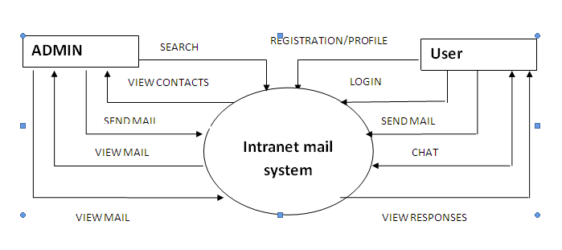

# FIRST LEVEL DFD

3.7.3.2. 1-LEVEL DFD:-

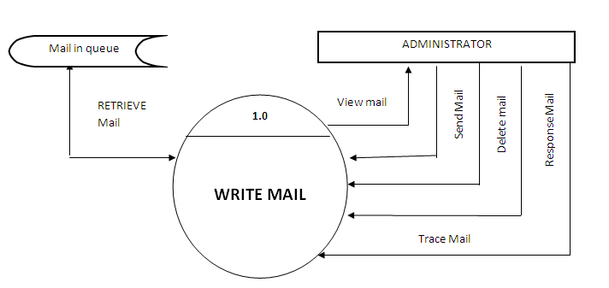

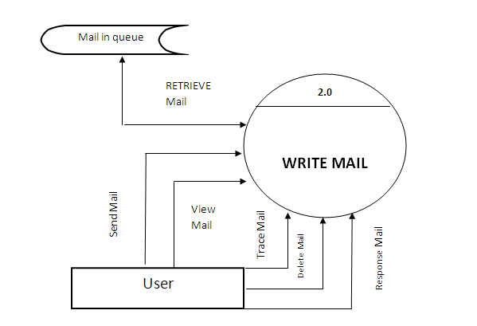

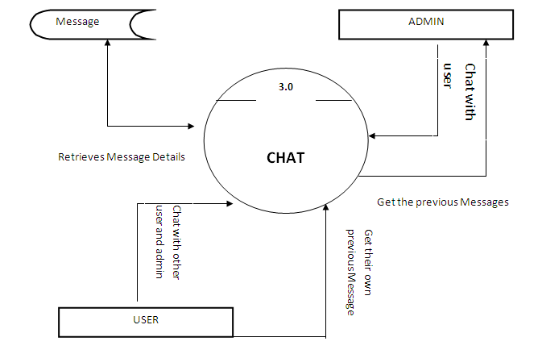

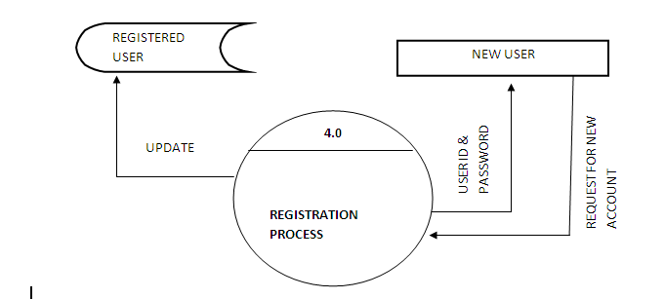

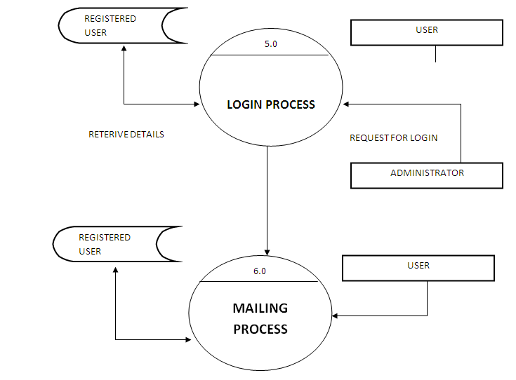

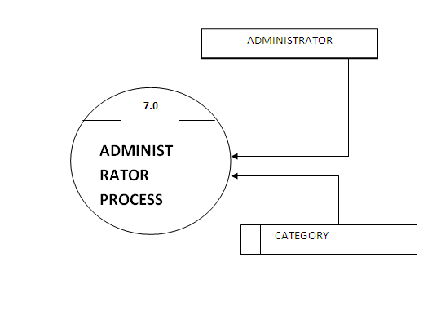

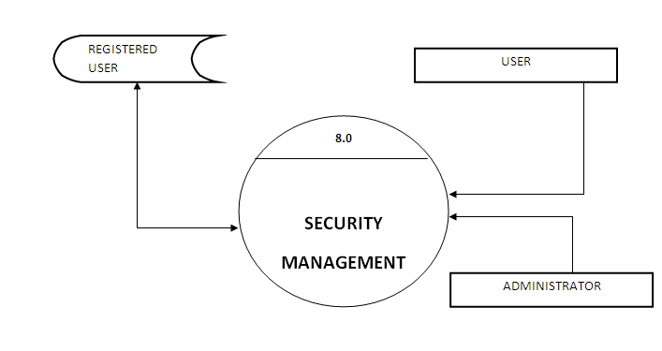

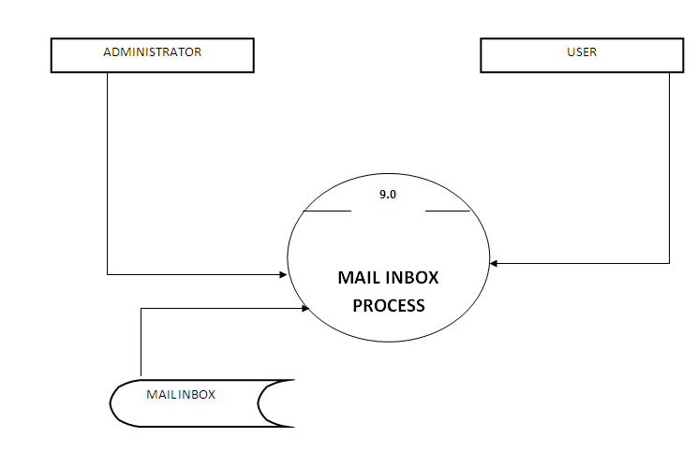

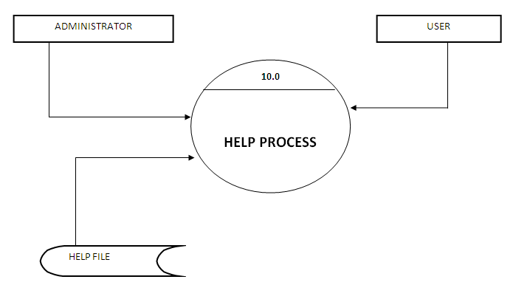

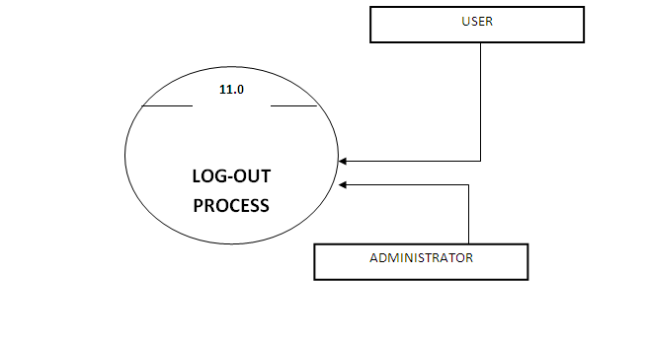

# Second Level DFD

3.7.3.3. 2-LEVEL DFD:-

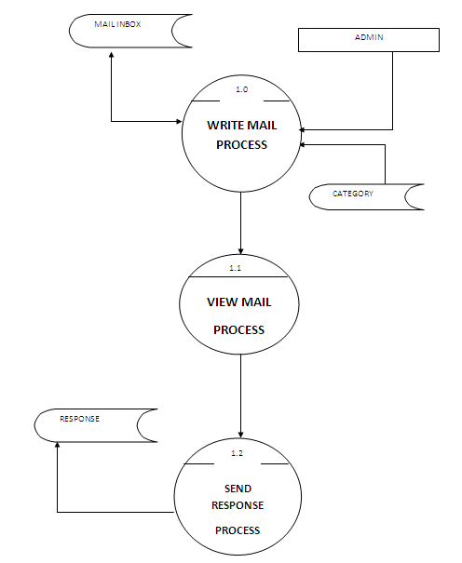

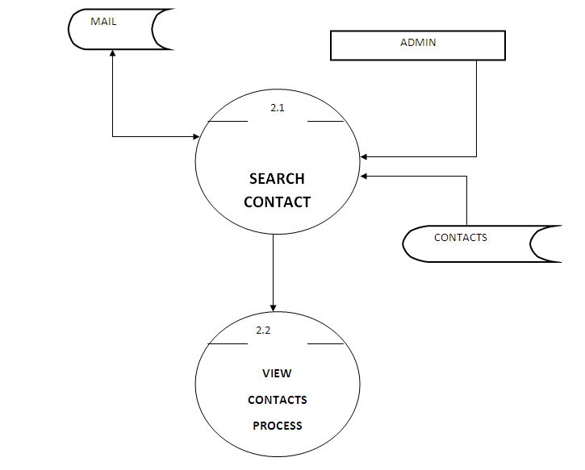

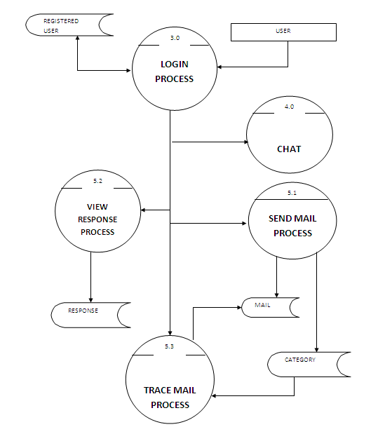

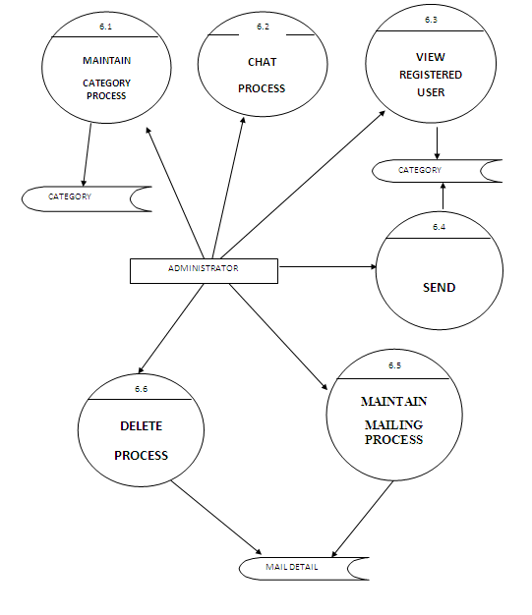

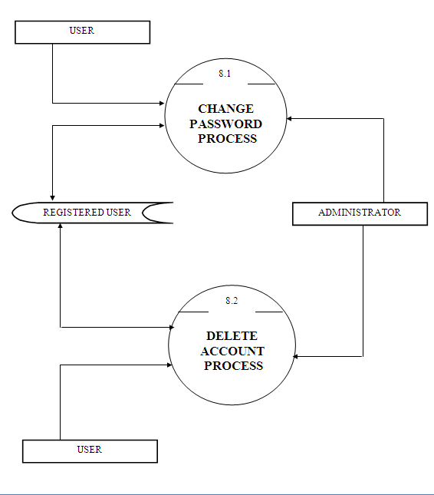

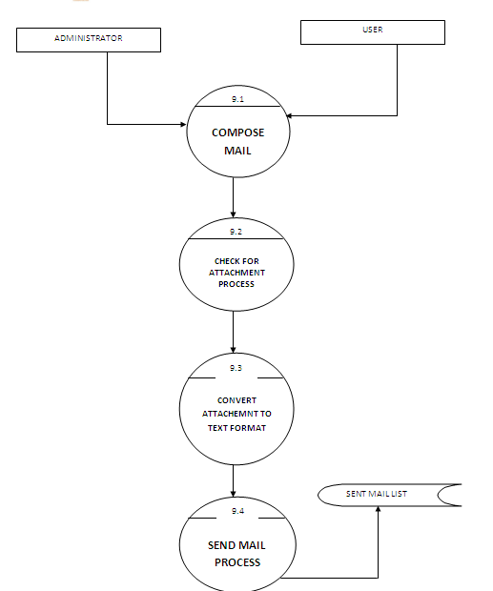

ENTITY RELATIONSHIP MODEL:-

3.7.1.1 ENTITIES AND THEIR ATTRIBUTES:-

1.

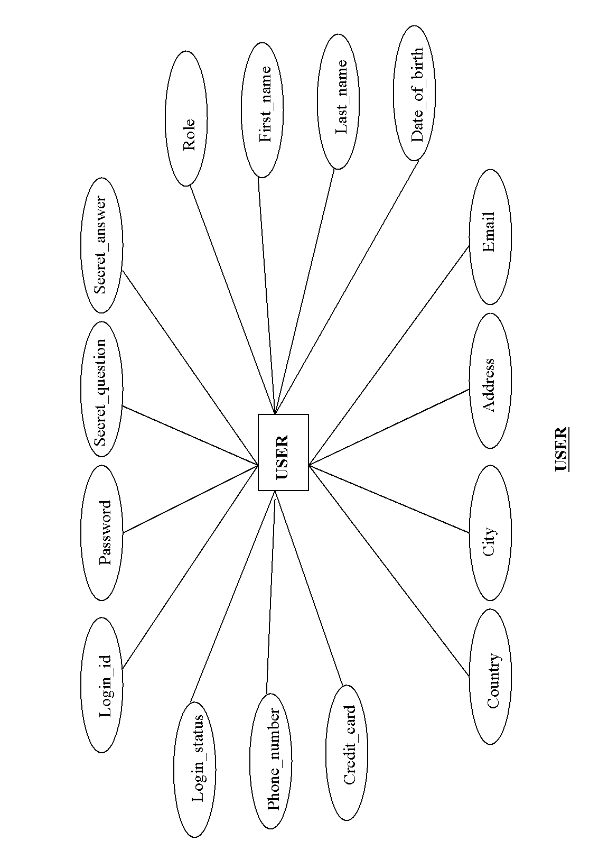

2.

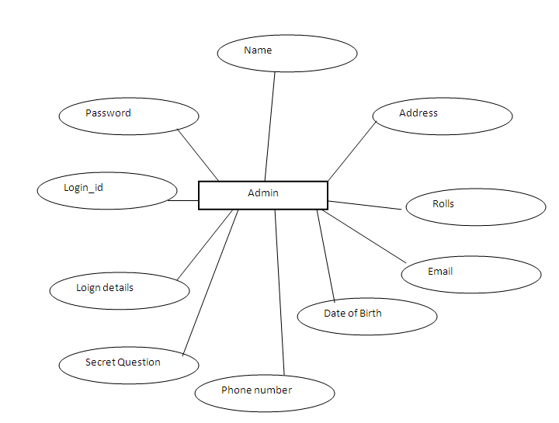

3.7.1.2 CONNECTIVITY:-

Relationship can be classified as one-to-one, one-to-many and many-to-many. The term connectivity is used to describe this relationship classification. In my system I identified the following connectivity:

3.7.1.3 E-R DIAGRAM:-

An entity-relationship (ER) diagram is a specialized graphic that illustrates the interrelationships between entities in a database. ER diagrams often use symbols to represent three different types of information. Boxes are commonly used to represent entities. Diamonds are normally used to represent relationships and ovals are used to represent attributes.

This diagramming technique is used to visually present a database schema or data model and was original proposed by Chen in the 1970s. There are many different data modeling notations; some are very similar to UML class diagrams (with the exception of operations). However, the notation the used here is slightly different, as proposed by Elmasri, et al.

The database schema for this system is shown in figure. The table object has been left out of the diagram because the table management feature set had been dropped from the requirements before this stage of the design process.

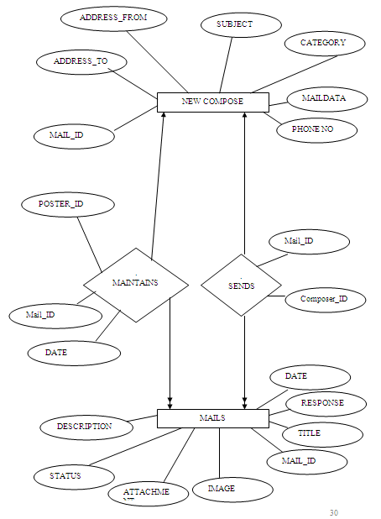

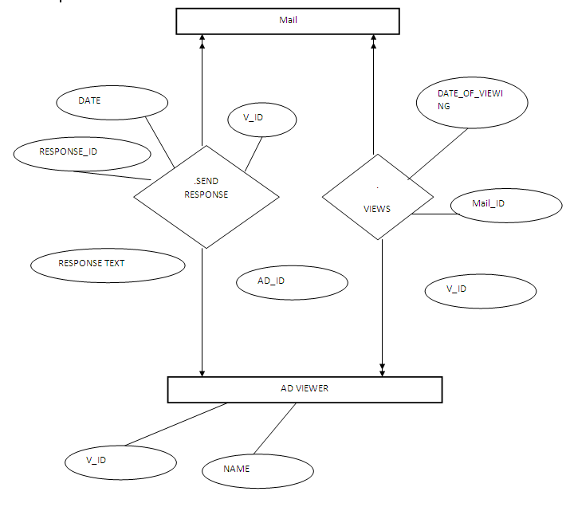

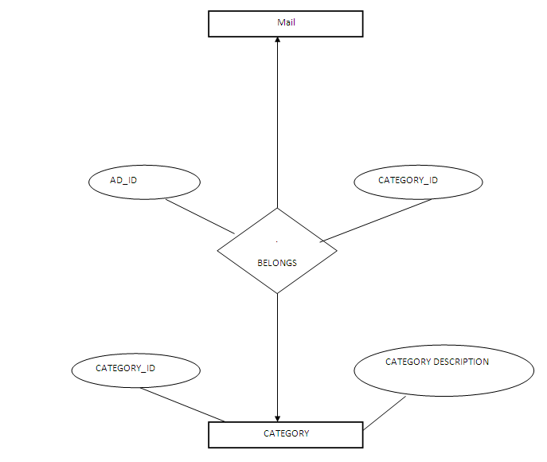

3.7.2 INTERACTION ANALYSIs:-

Interaction is the manner in which user interact with web application. In other words it is the procedure in which each components functions interact with other components of the system. Here we are concerned with the people who will use the system. We observe the manner they will interact with the system. in my system I have identified three kind of users, these are:

* Administrator
* Registered user

Here I take the help of use-case diagram to explain the whole situation.

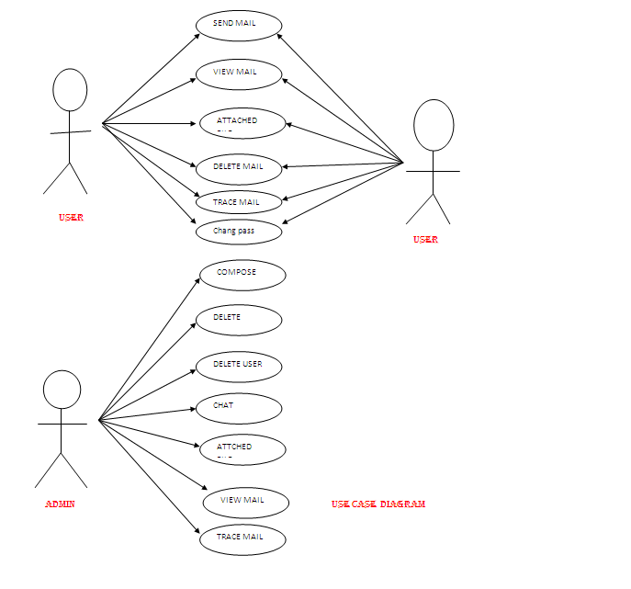

3.10 Description of Tools used:-

**LANGUAGE USED : JAVA**

Java is a purely object oriented language. Java language allows you to build very complete exception trapping and exception handling into your programs using its try-catch syntax. Java language is Portable, Extensible, Persistent and Robust. A java language also supports a both side architecture Client side and server side.

Java is high-level, third generation language like, C, FORTRAN, Small talk, pearl and many others. You can use java to write computer applications that crunch numbers, process words, play games, store data or do any of the thousands of other things computer software can do.

Special program called applet that can be downloaded from the internet and played safely within a web browser. Java supports this applications and the follow features make it one of the best programming languages.

* It is simple and object oriented
* It helps to create user friendly interfaces.
* It is very dynamic
* It supports multithreading
* It is highly secure and robust.
* It supports internet programming

Java is originally developed by Sun Microsystem and released in 1995 as a core component of Sun’s java platform. The language derives much of its syntax from C and C++ but has a simpler object model and fewer low-level facilities. Java applications are typically compiled to byte code which can run on any java virtual machin(JVM) regardless of computer architecture.

The original and reference implementation java compilers, virtual machins, and class libraries were developed by Sun from 1995. As of May 2007, in compliance with the specifications of the java Community process, Sun made available most of their java.

**Primary goals**

There were five primary goals in the creation of the Java language:

1. It should use the object-oriented programming methodology.
2. It should allow the same program to be executed on multiple operating systems.
3. It should contain built-in support for using computer networks.
4. It should be designed to execute code from remote sources securely.
5. It should be easy to use by selecting what were considered the good parts of other object-oriented languages.

The Java platform is the name for a bundle of related programs, or platform, from Sun which allow for developing and running programs written in the Java programming language. The platform is not specific to any one processor or operating system, but rather an execution engine (called a virtual machine) and a compiler with a set of standard libraries which are implemented for various hardware and operating systems so that Java programs can run identically on all of them.

Different "editions" of the platform are available, including:

* Java ME (Micro Edition): Specifies several different sets of libraries (known as profiles) for devices which are sufficiently limited that supplying the full set of Java libraries would take up unacceptably large amounts of storage.
* Java SE (Standard Edition): For general purpose use on desktop PCs, servers and similar devices.
* Java EE (Enterprise Edition): Java SE plus various APIs useful for multi-tier client-server enterprise applications.

The Java Platform consists of several programs, each of which provides a distinct portion of its overall capabilities. For example, the Java compiler, which converts Java source code into Java bytecode (an intermediate language for the Java Virtual Machine (JVM)), is provided as part of the Java Development Kit (JDK). The sophisticated Java Runtime Environment (JRE), complementing the JVM with a just-in-time (JIT) compiler, converts intermediate bytecode into native machine code on the fly. Also supplied are extensive libraries (pre-compiled into Java bytecode) containing reusable code, as well as numerous ways for Java applications to be deployed, including being embedded in a web page as an applet.There are several other components, some available only in certain editions.

The essential components in the platform are the Java language compiler, the libraries, and the runtime environment in which Java intermediate byte code "executes" according to the rules laid out in the virtual machine specification.

**JAVA VIRTUAL MACHINE:**

Java applications can run in the context of a Java Virtual Machine. A Java Virtual Machine is a runtime environment that executes a special from of Java binary code called byte code and converts this into appropriates calls for the local operating system.

The JVM byte code is what makes application code that is write once, run anywhere possible. As long as a JVM is available for a hardware-based platform Java application byte code will run on the hardware platform.

The Java API is a large collection of ready made software components that provide many useful capabilities such as Graphical User Interface [GUI] widgets and so on. The Java API is grouped into packages of related components.

**AUTOMATIC MEMORY MANAGEMENT**

One of the ideas behind Java's automatic memory management model is that programmers be spared the burden of having to perform manual memory management. In some languages the programmer allocates memory for the creation of objects stored on the heap and the responsibility of later deallocating that memory also resides with the programmer. If the programmer forgets to deallocate memory or writes code that fails to do so, a memory leak occurs and the program can consume an arbitrarily large amount of memory. Additionally, if the program attempts to deallocate the region of memory more than once, the result is undefined and the program may become unstable and may crash. Finally, in non garbage collected environments, there is a certain degree of overhead and complexity of user-code to track and finalize allocations. Often developers may box themselves into certain designs to provide reasonable assurances that memory leaks will not occur.

In Java, this potential problem is avoided by automatic garbage collection. The programmer determines when objects are created, and the Java runtime is responsible for managing the object's lifecycle. The program or other objects can reference an object by holding a reference to it (which, from a low-level point of view, is its address on the heap). When no references to an object remain, the Java garbage collector automatically deletes the unreachable object, freeing memory and preventing a memory leak. Memory leaks may still occur if a programmer's code holds a reference to an object that is no longer needed—in other words, they can still occur but at higher conceptual levels.

The use of garbage collection in a language can also affect programming paradigms. If, for example, the developer assumes that the cost of memory allocation/recollection is low, they may choose to more freely construct objects instead of pre-initializing, holding and reusing them. With the small cost of potential performance penalties (inner-loop construction of large/complex objects), this facilitates thread-isolation(no need to synchronize as different threads work on different object instances) and data-hiding. The use of transient immutable value-objects minimizes side-effect programming.

Comparing Java and C++, it is possible in C++ to implement similar functionality (for example, a memory management model for specific classes can be designed in C++ to improve speed and lower memory fragmentation considerably), with the possible cost of adding comparable runtime overhead to that of Java's garbage collector, and of added development time and application complexity if one favors manual implementation over using an existing third-party library. In Java, garbage collection is built-in and virtually invisible to the developer. That is, developers may have no notion of when garbage collection will take place as it may not necessarily correlate with any actions being explicitly performed by the code they write. Depending on intended application, this can be beneficial or disadvantageous: the programmer is freed from performing low-level tasks, but at the same time loses the option of writing lower level code. Additionally, the garbage collection capability demands some attention to tuning the JVM, as large heaps will cause apparently random stalls in performance.

Java does not support pointer arithmetic as is supported in, for example, C++. This is because the garbage collector may relocate referenced objects, invalidating such pointers. Another reason that Java forbids this is that type safety and security can no longer be guaranteed if arbitrary manipulation of pointers is allowed.

**PERFORMANCE**

Java's performance has improved substantially since the early versions, and performance of JIT compilers relative to native compilers has in some tests been shown to be quite similar. The performance of the compilers does not necessarily indicate the performance of the compiled code; only careful testing can reveal the true performance issues in any system.

**JAVA RUNTIME ENVIRONMENT**

The Java Runtime Environment, or *JRE*, is the software required to run any application deployed on the Java Platform. End-users commonly use a JRE in software packages and Web browser plugins. Sun also distributes a superset of the JRE called the Java 2 SDK (more commonly known as the JDK), which includes development tools such as the Java compiler, Javadoc, Jar and debugger.

One of the unique advantages of the concept of a runtime engine is that errors (exceptions) should not 'crash' the system. Moreover, in runtime engine environments such as Java there exist tools that attach to the runtime engine and every time that an exception of interest occurs they record debugging information that existed in memory at the time the exception was thrown (stack and heap values). These Automated Exception Handling tools provide 'root-cause' information for exceptions in Java programs that run in production, testing or development environments.

**Java 2 Enterprise Edition (J2EE)**

The J2EE platform uses a multitiered distributed application model. Application logic is divided into components according to function, and the various application components that make up a J2EE application are installed on different machines depending on the tier in the multitiered J2EE environment to which the application component belongs. Figure 1-1 shows two multitiered J2EE applications divided into the tiers described in the following list. The J2EE application parts shown in Figure 1-1 are presented in J2EE Components.

* Client-tier components run on the client machine.
* Web-tier components run on the J2EE server.
* Business-tier components run on the J2EE server.
* Enterprise information system (EIS)-tier software runs on the EIS server.

Although a J2EE application can consist of the three or four tiers shown in Figure 1-1, J2EE multitiered applications are generally considered to be three-tiered applications because they are distributed over three different locations: client machines, the J2EE server machine, and the database or legacy machines at the back end. Three-tiered applications that run in this way extend the standard two-tiered client and server model by placing a multithreaded application server between the client application and back-end

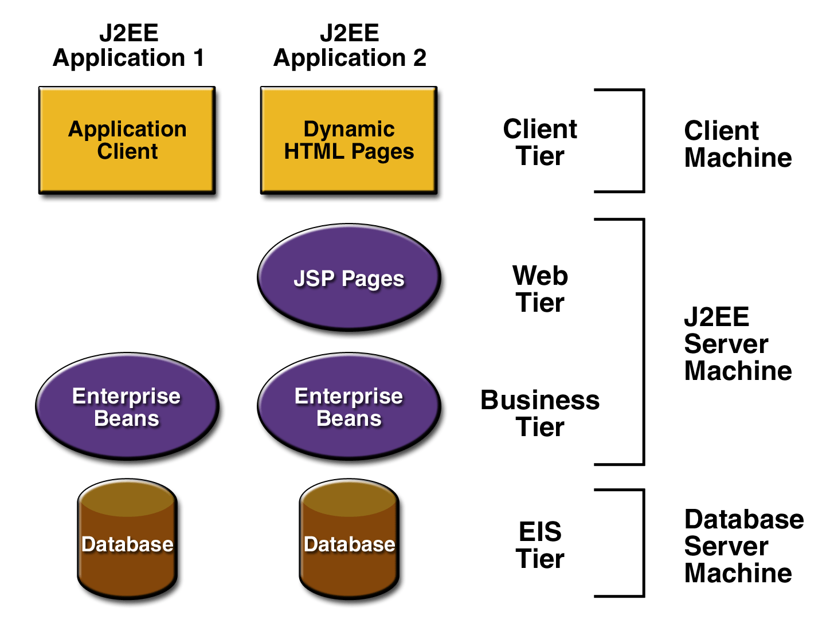

**Figure 1-1 Multitiered Applications**

**J2EE COMPONENTS**

J2EE applications are made up of components. A *J2EE component* is a self-contained functional software unit that is assembled into a J2EE application with its related classes and files and that communicates with other components. The J2EE specification defines the following J2EE components:

* Application clients and applets are components that run on the client.
* Java Server and Java Server Pages (JSP) technology components are Web components that run on the server.
* Enterprise JavaBeans (EJB) components (enterprise beans) are business components that run on the server.

J2EE components are written in the Java programming language and are compiled in the same way as any program in the language. The difference between J2EE components and "standard" Java classes is that J2EE components are assembled into a J2EE application, verified to be well formed and in compliance with the J2EE specification, and deployed to production, where they are run and managed by the J2EE server.

**J2EE CLIENTS**

A J2EE client can be a Web client or an application client.

**WEB CLIENTS**

A Web client consists of two parts: dynamic Web pages containing various types of markup language (HTML, XML, and so on), which are generated by Web components running in the Web tier, and a Web browser, which renders the pages received from the server.

A Web client is sometimes called a *thin client*. Thin clients usually do not do things like query databases, execute complex business rules, or connect to legacy applications. When you use a thin client, heavyweight operations like these are off-loaded to enterprise beans executing on the J2EE server where they can leverage the security, speed, services, and reliability of J2EE server-side technologies.

**APPLETS**

A Web page received from the Web tier can include an embedded applet. An applet is a small client application written in the Java programming language that executes in the Java virtual machine installed in the Web browser. However, client systems will likely need the Java Plug-in and possibly a security policy file in order for the applet to successfully execute in the Web browser.

Web components are the preferred API for creating a Web client program because no plug-ins or security policy files are needed on the client systems. Also, Web components enable cleaner and more modular application design because they provide a way to separate applications programming from Web page design. Personnel involved in Web page design thus do not need to understand Java programming language syntax to do their jobs.

**APPLICATION CLIENT**

A J2EE application client runs on a client machine and provides a way for users to handle tasks that require a richer user interface than can be provided by a markup language. It typically has a graphical user interface (GUI) created from Swing or Abstract Window Toolkit (AWT) APIs, but a command-line interface is certainly possible.

Application clients directly access enterprise beans running in the business tier. However, if application requirements warrant it, a J2EE application client can open an HTTP connection to establish communication with a servlet running in the Web tier.

**JAVABEANS COMPONENT ARCHITECTURE**

The server and client tiers might also include components based on the JavaBeans component architecture (JavaBeans component) to manage the data flow between an application client or applet and components running on the J2EE server or between server components and a database. JavaBeans components are not considered J2EE components by the J2EE specification.

JavaBeans components have instance variables and get and set methods for accessing the data in the instance variables. JavaBeans components used in this way are typically simple in design and implementation, but should conform to the naming and design conventions outlined in the JavaBeans component architecture.

**J2EE SERVER COMMUNICATION**

The client communicates with the business tier running on the J2EE server either directly or, as in the case of a client running in a browser, by going through JSP pages or servlets running in the Web tier.J2EE application uses a thin browser-based client or thick application client. In deciding which one to use, you should be aware of the trade-offs between keeping functionality on the client and close to the user (thick client) and off-loading as much functionality as possible to the server (thin client). The more functionality you off-load to the server, the easier it is to distribute, deploy, and manage the application; however, keeping more functionality on the client can make for a better perceived user experience.

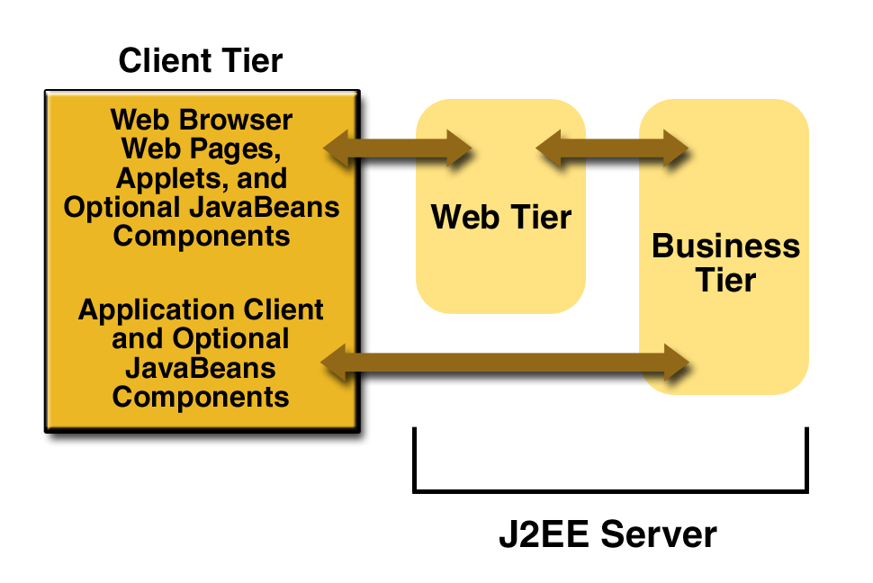

**Figure 1-2 Server Communications**

**WEB COMPONENT**

J2EE Web components can be either servlets or JSP pages. *Servlets* are Java programming language classes that dynamically process requests and construct responses. *JSP pages* are text-based documents that execute as servlets but allow a more natural approach to creating static content.Static HTML pages and applets are bundled with Web components during application assembly, but are not considered Web components by the J2EE specification. Server-side utility classes can also be bundled with Web components and, like HTML pages, are not considered Web components.Like the client tier and as shown in Figure 1-3, the Web tier might include a JavaBeans component to manage the user input and send that input to enterprise beans running in the business tier for processing.

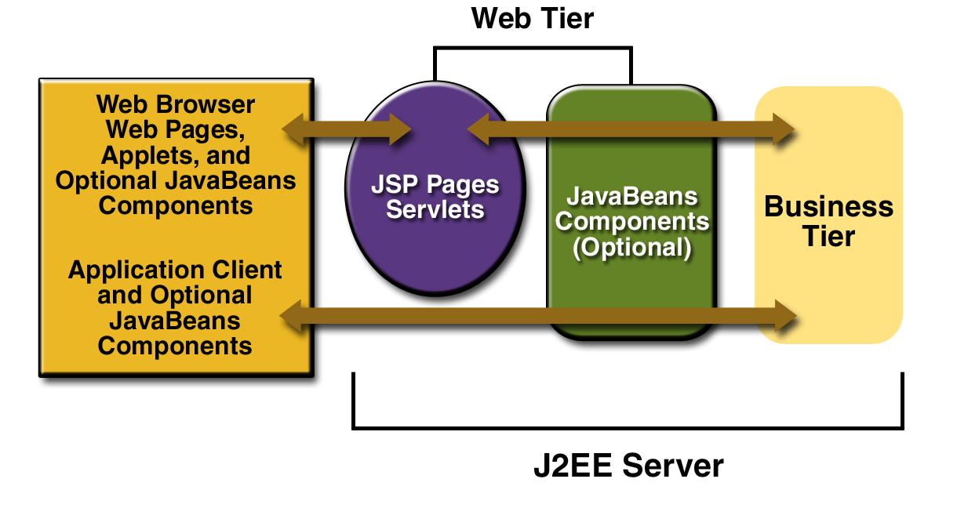

**Figure 1-3 Web Tier and J2EE Application**

**BUSINESS COMPONENT**

Business code, which is logic that solves or meets the needs of a particular business domain such as banking, retail, or finance, is handled by enterprise beans running in the business tier. An enterprise bean also retrieves data from storage, processes it (if necessary), and sends it back to the client program.

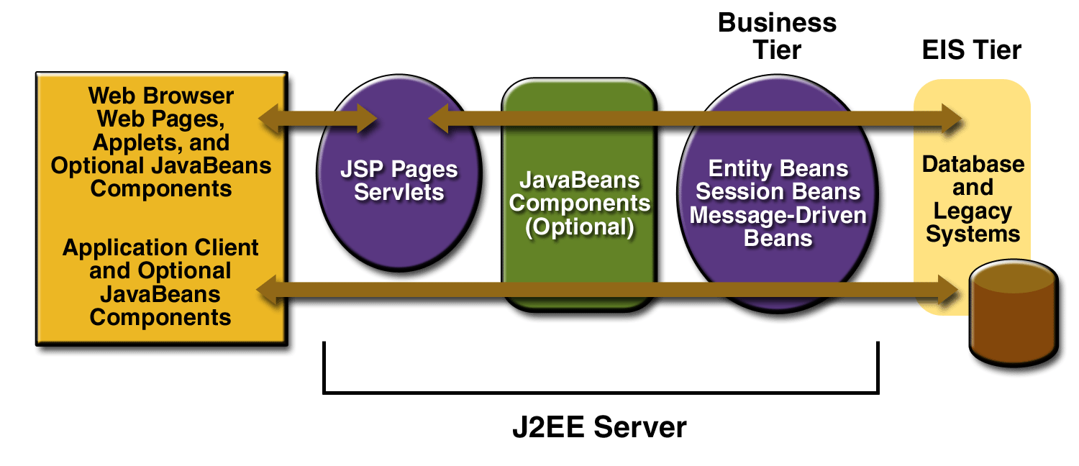

1. **Figure 1-4 Business and EIS Tiers**

There are three kinds of enterprise beans: session beans, entity beans, and message-driven beans. A *session bean* represents a transient conversation with a client. When the

client finishes executing, the session bean and its data are gone. In contrast, an *entity bean* represents persistent data stored in one row of a database table. If the client terminates or if the server shuts down, the underlying services ensure that the entity bean data is saved.

A *message-driven bean* combines features of a session bean and a Java Message Service (JMS) message listener, allowing a business component to receive JMS messages asynchronously. This tutorial describes entity beans and session beans.

**JSP ( JAVA SERVER PAGE ):**

JSP technology of Java Server Pages technology is an extension of Java programming technology. JSP includes a scripting language that is Java based. A JSP page on compilation generates a servlet. Web applications that are developed by using JSP demonstrate platform and Web Server allows Java to be embedded directly into an HTML page by using special tags.

Although JSP clearly defines the work profiles of a web designer and a web developer or programmer, facilitating easy application development, there some instances that require explicit use of servlets. File type format support to extend web servers functionality: To add support for a new file format, a servlet can easily be mapped to the specified format, as is the case in the compilation cycle of a JSP page. The servlet is simply mapped to the JSP files. As a result, files with jsp extension are parsed and complied to generate servlets. The servlet is subsequently processed to generate the response that is sent back to the browser.

The JSP is a presentation centric application development tool that can be used to handle both static and dynamic contents of a Web application.

On the basis of functional requirements of the proposed system, JSP seems to be appropriate tool for the development. With the advent of the Internet, the monolithic application architecture changed to the multi-tired client-server architecture. The need for server side scripting gradually began to dominate aspects of Web programming.

**APPLICATION SERVER : WEBLOGIC SERVER**

Application server is implemented based on the J2EE standards and acts a platform for implementing various server-side technologies, such as servlets, Java Server Pages (JSP). The server contains a set of policies and APIs that help to implement the same. The solutions that are offered by J2EE are not specific to a particular vendor or any API. For a JSP page or html page to be accessible from client, first it has to be deployed on the web server. A JSP page can be deploy in J2EE Server. JAVA 2 Enterprise Edition (J2EE) is a set of specification that defines the standards for creating distributed objects. J2EE also specifies how these technologies can be integrated to provide a complete solution. It is also a standard architecture that defines a multi tier programming model. The Java 2, Enterprise Edition (J2EE) server is a product from Sun Microsystems that is based on the Java2 Enterprise Edition (J2EE). The server is used to deploy servlets and JSP files and enable users to access the same by implementing appropriate security.

**JDBC (JAVA DETABASE CONNECTIVITY)**

In 1996, JavaSoft released its first version of the JDBC kit. JDBC stands for Java database Connectivity. This is actually an API, which consists of a set of Java classes, interfaces and exceptions bound to a specification. JDBC driver vendors and developers who use JDBC must adhere to this specification when developing applications. Applications developed with Java JDBC are platform and database vendor independent i.e. the same Java program can simply by changing the JDBC middleware.

An idea similar to Microsoft’s Open DataBase Connectivity [ODBC] is the JDBC underlay. JDBC [and ODBC] are based on the X/Open SQL Call level Interface [CLI], which is the basis for the ODBC standard for database connectivity. Programs written using the JDBC API communicate with a JDBC driver manager, which uses driver specifically loaded to communicate with the DB engine.

JDBC is today a mature and well-accepted table data, access and standard. RDBMS [Relational DataBase Management Systems] or third-party vendors develop database specific driver, which adhere to the JDBC specification. Application developers use these drivers in their applications, to access appropriate database tables.

Developers use these drivers to develop applications, which access the respective database. The JDBC application developers can easily replace one driver for their application with another better one without having to alter the application as the drivers are adhered to JDBC specification. If some proprietary API provided by some RDBMS vendor is used for developing Java applications, it becomes mandatory to modify a substantial amount of application in order to switch to other driver and/or database.

With JDBC in place the developers can develop Java data access applications without having to learn and use proprietary APIs provided by different RDBMS. The developer only needs to learn JDBC and the data access applications can be developed conveniently that can access different RDBMS and/or using different JDBC drivers.

Although relational databases are most common databases, JDBC can be used with any kind of database. The main reason behind this is JDBC concepts common database functions into a set of common classes and methods. Database specific code is contained in a code library, which is called as a driver library. With the driver library for a database, JDBC API can be used to send commands to the database and extract data from the database.

**Advantages of JDBC:**

The following are the advantages of JDBC:

* While using JDBC, businesses are not limited to any proprietary architecture and can proceed to use their installed databases and to access information, which may be stored on the same or different DBMS.
* The combination of Java API and the JDBC API results into the easy and economically more efficient application development. JDBC overcomes with complexity of many data access tasks. JDBC API is simple to learn, easy to deploy and inexpensive to maintain as it simplifies enterprise development.
* With JDBC API, no configuration is required to establish a connection with a driver written in Java Naming and Directory Interface [JNDI] naming service which defines all the information required to establish a connection with written in Java programming language.
* JDBC API is available everywhere on the Java EE 5 platform, which provides support for Write Once, Run Anywhere paradigm as the developers can actually write database application once and access data anywhere.
* The JDBC API facilitates the development of sophisticated applications by providing metadata access. These sophisticated applications are needed to recognize essential facilities and capabilities of a database connection.

**HTML:**

Hypertext Markup Language was developed by a consortium of organizations, the World Wide Web consortium (W3C). HTML is a set of tags and elements used to create Web pages. Web pages are documents that you view on the Web. Web pages are stored as files with the extension .htm or .html. HTML is a web based language. It is very easy to learn and use.

**JAVA SCRIPT:**

Java script is a scripting language. To develop interactive Web sites, you need to create a Web interface for accepting data from users. The data accepted can be stored for further processing and validation. So we use the Java Script. You will also be able to write Java Script code to validate the data entered by users on the Web sites, handle run-time and execution errors in Web documents, and communicate with the users by displaying messages. To create interactive Web documents, the language used is Hypertext Markup Language (HTML). However, HTML does not support data processing on the client computer. Therefore any data in HTML that needs to be validated is sent for processing to the server, causing delay. To facilitate data validated is sent for processing toe the server, causing delay. To facilitate data validation on the client-side, you can use a scripting language for creating interactive interfaces on the Web.

**CSS:-**

CSS stands for Cascading Style Sheet. It defines a way how the information is presented by all the browsers on the web. A style sheet is a set of rules that controls the formatting of HTML elements on one or more web pages. Thus, the appearance of a Web page can be changed by changing the style sheet associated with it. There is no need to make detailed changes within the Web page to change how it looks. As one style sheet can be used for a whole web site, it normally means that the overall size of the website is smaller and downloads required for each page can be decreased by up to 40%.

**BACK-END : RDBMS:**

The proposed system falls under RDBMS (Relational Database Management System) category. I have adopted JSP as front end for the software and **MySql** as back end. JSP is at present one of the most popular development platform for Web based system in both side Client-Side and Server-Side.

**MySql** is at present the most reliable and secure RDBMS tool. **MySql** works to efficiently manage its resource, a database of information, among the multiple clients requesting and sending data in the network. **MySql** has many important features that make it not only an exceptional database management system but also an excellent database server choice for client/server database computing.

So the overall system will prove too reliable, secure and efficient for the organization.

**MySql**, a Relational Database Management System (RDBMS), works to efficiently manage its resource, a database of information, among the multiple clients requesting and sending data in the network. **MySql** has many important features that make it not only an exceptional database management system but also an excellent database server choice for client/server database computing. Here are some of these features:

* Its supports Microsoft 2000 and higher version
* It has client/server features developers can use to minimize the network traffic between client and server. Therefore, application based on **MySql** can deliver the performance that users require to the productive in their jobs.

It maintains database security using a system of access controls. This simply means that at an administrator's discretion, the administrator create registered database user and then grants them the privileges to perform specific database operation and use specific data.

**4. SYSTEM DESIGN**

System Design is the critical module in the software development after the System Analysis. Design is the technical Kernel of Software engineering. Design is a meaningful engineering representation of something. It can be traced to a customer’s requirements and at the same time accessed for quality against a set of predefined criteria for good design. It involves lot of intersection with the users; it has to be flexible and dynamic to meet the changing needs of the users over a period of time.

So, now we are in design phase. System Design is based on the requirement analysis and specification, generated in analysis phase. The design phase focuses on the detailed implementation of the system recommended in the feasibility study.

Software design is an iterative process through which requirements are translated into a ‘blueprint’ for constructing the software. Throughout the design process, the quality of the evolving design is accessed with a series of formal technical reviews or design walkthroughs.

McGlaughlin [MCG 91] suggest three characteristics that serve as a guide for the evaluation of a good design-

* The design must implement all of the explicit requirements contained in the analysis model, and it must accommodate all of the implicit requirements desired by the customer.
* The design must be a readable, understandable guide for those who generate code and those who test and subsequently support the software.
* The design should provide a complete picture of the software, addressing the data, functional and behavioral domains from an implementation perspective.

Each of these characteristics is actually goal of the design process. In order to evaluate the quality of design representation, we must establish technical criteria for good design. I follow the following guidelines-

* A design should exhibit an architectural structure that:
  + Has been created using recognizable design patterns.
  + Is composed of components that exhibit good design characteristics.
  + Can be implemented in an evolutionary fashion, thereby facilitating implementation and testing.
* A design should be modular, i.e., the software should be logically portioned into elements that perform specific functions and sub functions.
* A design should contain distinct representations of data, architecture, interfaces and components (modules).
* A design should lead to data structures that are appropriate for the objects to be implemented and are drawn from recognizable data patterns.
* A design should lead to components that exhibit independent functional characteristics.
* A design should lead to interfaces that reduce the complexity of connections between modules and with the external environment.
* A design should be derived using a repeatable method that is driven by information obtained during software requirements analysis. During the system design method, we apply a set of fundamental principles and basic concepts to data, architectural, interface and component level design. Basic design principles enable to navigate the design process.
* System design is a solution “How to approach” to the creation of the new system. This important phase is composed of several steps. It provides the undertaking and procedural feasibility study. Design goes through a logical and physical stage of development. Logical design reviews present physical stage of development ,prepares input/output specification and security and walkthrough.

INPUT DESIGN:-

The common cause of error in data processing inaccurate input data error entered by the data operator can be controlled by the input design.The goal of input design is to make data entry as easy ,logical and free of errors as possible.

OUTPUT DESIGN:-

Computers are the most important sources of information to the users. Inputs are fed into the computers to acquire the necessary outputs.The computer can provide the well enough output in the form of information regarding various items to the users .The major form of output is the hard copy from the printe

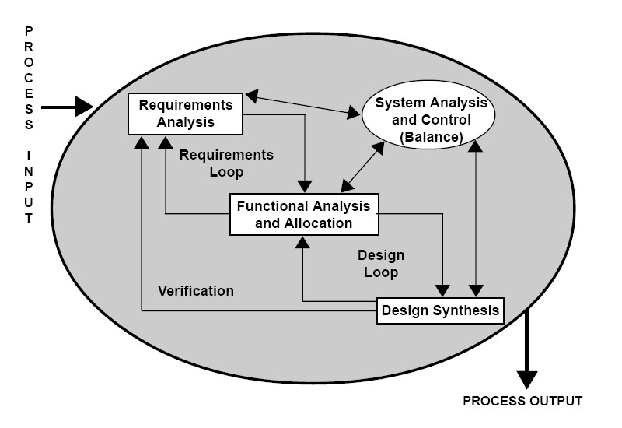

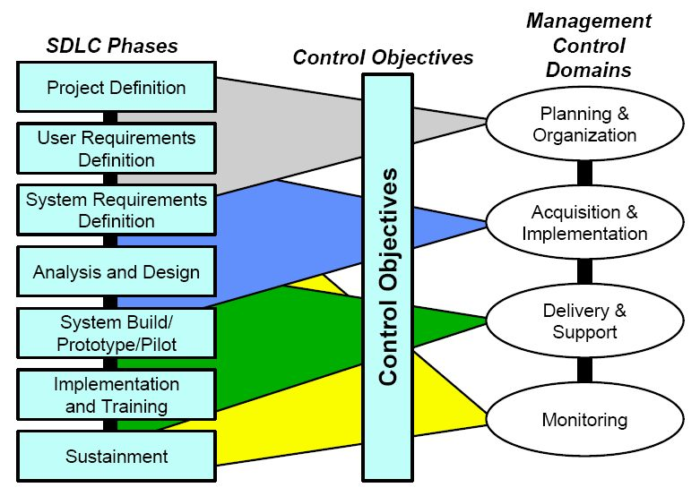

**4. 1. MODULARISATION DETAILS**

4.1.1 DATABASE DESIGn:- Database designs transform the information domain model created during analysis into the data structures that will require implementing the software.

4.1.1.1 ENTITIES AND THEIR ATTRIBUTEs:-

1. User(Login_id, Password, Secret_question, Secret_answer, Role, First_name, Last_name, Date_of_birth, Email, Address, City, Country, Credit_card, Phone_number, Login_status)

Primary Key: Login_id

2. NewCompose(MailID, Mailfrom, Mailto, Subject, Mailcc, MailBcc, MailData, folder, MailDate, MailSt)

Primary Key: MailID

3. Signupdetails(Uname, passwd, Age,Sex, City, State, Pin, County)

Primary Key: Uname

Foreign Key: Album_id

4. newfolder(MID,MFrom,MTo, Mcc, MData,Folder,MailSt, MailDate)

5. address(ActName, Uname, NickName, EmailID, Address Phone)

6. chatMessage(Username, message, date, response_id, response_text)

Primary Key: (Username)

7. Search(Mid, MialDate, Dateofview)

Primary Key: Mid

8. Category(Category_id, Category_name, Category_description)

Primary Key: (Catetory_id)

9.Login(username, password, status)

Primary Key: username

4.1.1.2.NORMALIZATION:-

In database design we also use the normalization concepts. Normalization is used to ensure that various types of anomalies and inconsistencies are not introduced in to database. Normalization is used to remove redundancy and different type of anomalies like insertion, deletion,and updation anomalies.With the help of normalization concepts accessing ofdatabase made easier and data stored in consistent manner.

A.FIRST NORMAL FORM:-

“A relation is said to be in first normal form(1NF) if the values in the domain of each attribute of the relation are atomic. In other words, only one value is associated with each attribute and the value is not a set of values or a list of values. A database scheme is in 1NF, if every relation scheme included in the database scheme is in 1NF”.In my project all relations are holding the atomic values from their domain to the corresponding attributes. So, in my project, database is in normalizing form. All relations are in 1NF.

B.SECOND NORMAL FORm:-

A second normal form does not permit partial dependency between non-prime attribute and the relation keys.

“A relation scheme R<S, F> is in second normal form (2 NF) if it is in 1NF and if all non prime attributes are fully functionally dependent on the relation key(s).”

In my project database already is in 1 NF and also have no partial dependency between a non-prime attribute and the relation key(s). The key of all the relations are as follows:

|  |  |
| --- | --- |
| **RELATION** | **PRIMARY KEY** |
| User | Login_id |
| NewCompose | Mail_id |
| SignupDetails | uname |
| NewFolder | Mail_id |
| Address | uname |
| ChatMessage | uname |
| Search | M_id |
| Category | Catetory_id |
| Login | uname |

C. THIRD NORMAL FORm:- “A relation scheme R is in third normal form (3 NF) with respect to a set of functional dependencies if, for all functional dependencies if F+ of the form X->Y where X and Y are in R, at least one of the following holds:

* X -> Y
* X is a super key of R

A relation scheme in third normal form does not allow partial or transitive dependencies. So, my tables are in 3 NF because every nonprime attribute is non-transitively and fully dependent on the key. In my project there is no transitive dependency in that relation, so the relation and database is in the third normal form.

4.1.1.3 TABLE STRUCTURE :-

1.

**newcompose:** This table maintains details of composed mail

|  |  |  |
| --- | --- | --- |
| **Field name** | **Null?** | **Data type** |
| MailId | NOT NULL | Int |
| Mailfrom |  | Varchar(50) |
| Mailto |  | Varchar(50) |
| Subject |  | Varchar(80) |
| Mailcc |  | Varchar(50) |
| MailBcc |  | Varchar(50) |
| MailData |  | Varchar(99) |
| Folder |  | Varchar(50) |
| MailDate |  | Varchar(35) |
| MailSt |  | Int |

2.

**folder:** This table maintains details of composed item.

|  |  |  |
| --- | --- | --- |
| **Field Name** | **Null?** | **Data Type** |
| uname | NOT NULL | Varchar(50) |
| Att_item | NOT NULL | Varchar(50) |

3.

**Signupdetails:** This table contains signupdetails .

|  |  |  |
| --- | --- | --- |
| **Field Name** | **Null?** | **Data Type** |
| Uname | NOT NULL | Varchar(50) |
| Passwd |  | Varchar(30) |
| Age |  | Int |
| Sex |  | Varchar(6) |
| City |  | Varchar(50) |
| State |  | Varchar(50) |
| Pin |  | Varchar(20) |
| Country |  | Varchar(40) |

4.

**newfolder:** This table maintains details of mail.

|  |  |  |
| --- | --- | --- |
| **Field Name** | **Null?** | **Data Type** |
| MID | NOT NULL | Int |
| MFrom |  | Varchar(40) |
| MTo |  | Varchar(40) |
| Sub |  | Varchar(40) |
| Mcc |  | Varchar(40) |
| MData |  | Long |
| Folder |  | Varchar(15) |
| MailSt |  | Int |
| MailDate |  | Varchar(35) |

5.

**address:** This table maintains detail of address of users

|  |  |  |
| --- | --- | --- |
| **Field Name** | **Null?** | **Data Type** |
| ActName |  | Varchar(50) |
| Uname |  | Varchar(50) |
| NickName |  | Varchar(50) |
| EmailId |  | Varchar(50) |
| Addresses |  | Varchar(99) |
| Phone |  | Int |

6.

**ChatMessage:** This table maintains date of message.

|  |  |  |
| --- | --- | --- |
| **Field Name** | **Null?** | **Data Type** |
| Username | NOT NULL | Varchar(40) |
| Message |  | Varchar(40) |
| Date |  | Varchar(30) |
| Response_id |  | Int |
| Response_text |  | Varchar(99) |

7.

**Search:** This table contains the data to be search

|  |  |  |
| --- | --- | --- |
| **Field Name** | **Null?** | **Data Type** |
| Mid | NOT NULL | Int |
| MailData |  | Varchar(99) |
| Date of view |  | Varchar(40) |

8.

**Category:** This table defines the category for mails**.**

|  |  |  |
| --- | --- | --- |
| **Field Name** | **Null?** | **Data Type** |
| Category_id | NOT NULL | Int |
| Category_name |  | Varchar(50) |
| Category_description |  | Varchar(99) |

6.

**Login**: This stores the users loginid.

|  |  |  |
| --- | --- | --- |
| **Field Name** | **Null?** | **Data Type** |
| Username | NOT NULL | Varchar(40) |
| Password |  | Varchar(40) |

4.1.2 ARCHITECTURAL DESIGN:-

The architectural design defines the relationships between major structural elements of the software, the “design patterns” that can be used to achieve the requirements that have been defined for the system, and the constraints that affect the way in which architectural design patterns can be applied.

Architectural design represents the structure of data and program components that are required to build a computer-based system. It considers the architectural style that the system will take, the structure and properties of the components that constitute the system, and the interrelationships that occur among all architectural components of a system

Architectural design begins with data design and then proceeds to the derivation of one or more representations of the architectural structure of the system. Alternative architectural styles or patterns are analyzed to derive the structure that is best suited to customer requirements and quality attributes. Once an alternative has been selected, the architecture is elaborated using an architectural design method.

Architectural design for web based systems and applications focus on the definition of the overall hypermedia structure of the web application and the application of design patterns. For architectural design I choose the Hierarchal with optional flow structures when developing the design for a typical web application.

Hierarchal with optional flow structure are the most common web application architecture. A web application Hierarchal structure can be designed in a manner that enables flow of control horizontally, across vertical branches of the structure.

In my system, the home page is connected to various components such as visitor, user and admin that can access the main page and then go ahead. Admin can login through the login page and go to the admin home page by which admin can do all activities (modifications or updating) in the system. User can login through the login page for buying items and giving feedbacks. Where as, any visitor can access the chart topper, new releases, album list and vote page.

4.1.3 NAVIGATIONAL DESIGN:-

After the established the web application architecture and components (pages, scripts and other processing function) of the architecture have been identified, then I must have to define the navigation pathways. Through the navigation, user enable to access web application contents and services. In navigation design, a large web application has a variety of different user role.

In my system there are two type of users. These are:

* Registered user
* Admin

Now I present the navigational design for each of these user.

**4.2. DATA INTEGRITY AND CONSTRAINS**

4.2.1 DATA INTEGRITy:-

Data Integrity provides accurate and consistent data to the databases. Therefore, data value being entered for storage could be checked to ensure that they fall within a specified range and are of the correct format. It plays major role for good project. Also it reduces the data ambiguity. Database Constraints like Primary Key, Unique key, and Alternate Key have been used in the project.

The new system may require some data from another computerized system or may provide data to another system in which case the files must be compatible in format and the system must operate with a certain processing cycle.

The relational model includes two general integrity rules.These integrity rules implicitly or explicitly define the set of consistence database states, or change of states, or both. There are following type of integrity rules:

A. ENTITY INTEGRITy:-It states that “ If the attribute A of relation R is a prime attribute of R, then A cannot accept null values.

In my project I have maintained the entity integrity by making it sure that no prime key have null value. Following are the relations I used and their corresponding prime attributes:

|  |  |
| --- | --- |
| **RELATION** | **PRIMARY KEY** |
| User | Login_id |
| NewCompose | Mail_id |
| SignupDetails | uname |
| NewFolder | Mail_id |
| Address | uname |
| ChatMessage | uname |
| Search | M_id |
| Category | Catetory_id |
| Login | uname |

B. REFERENTIAL INTEGRITy:- This rule is concerned with the foreign keys, i.e, with attributes of a relation having domains that are those of primary key of another relation. Referential integrity can be stated as: “Given two relations R and S, suppose R refers to the relation S via a set of attributes that forms the primary key of S and this set of attributes forms a foreign key in R. Then the value of the foreign key in a tuple R must either be equal to the primary key of a tuple of S or be entirely null.”

Referential integrity is very important. Because the foreign is used as a surrogate for another entity, the rule enforces the existence of a tuple for the relation corresponding to the instance of the referred entity. Here I have considered the referential integrity and implemented in my database.

4.2.2 CONSTRAINTs:-

Database systems are designed to represented the real world systems. The database systems require certain controls and limits for it to truely represent the real world system’s behavior. These limits or controls are called constraints in the database parlance. There are many kind of database constraints. Some of the constraints I have used in this database are:

A. Structural Constraints:- The structure of the information within the database gives an idea about entities in the database. In my database most of the field are of varchar type. But the song_location field of the song table is Blob. Blob stands for binary large object. It stores large binary object inside or outside row. It is typically used for multimedia data such as images, audio and video. Also there are fields which accept date/time format.

B. Type Constraints:- A type constraints limits the application to only one representation of information for an entity’s attribute.Most of the attributes are of varchar type size of which varies from 2 to 20.The message attribute of feedback relation is of size 50.

C. Range Constraints: Range constraints limit the values an attribute can take. It refers to the possible values that a particular data item can have. Range constraints can be used to limit the value of a particular attribute to be in a range

These are the requirements that are not directly related to the functionality of the system. These should be considered as mandatory when the system is developed. The following Constraints were arrived at for the system:

* The system should be connected with the server, so that, any customer in the premises can access the system.
* For gaining entry into the system, the users should be registered and should be able to use login and password for gaining access to the system.
* The users should be able to change their passwords for increased security.
* The system should be easy to understand and organized in a structured way. The users should also receive feedback about any errors that occur.
* There should be no limitation about the hardware platform that is to be used to run the system.
* Data Integrity should be maintained if an error occurs or the whole system comes down***.***

# Implementation Approaches:

Design Patterns:- This system uses two design patterns, which are as follows:

* Model View Controller(MVC) [for implementing business logic and view]
* Data Access Object(DAO) [For data access]

1. Model View Controller(MVC):- In the MVC design pattern, the application is divided into three parts:

* Model: Represents information about a domain. The information can be the application data of a J2EE application. This is the data and business-logic component. In J2EE applications EJB/JavaBeans represent the model.
* View: Represents the presentation logic to provide the data of the model. There can be more than one view of the same model. In J2EE applications, JSP represents the view.
* Controller: Represents the logic that coordinates the view and the model parts. The controller handles events fired by the view and calls the corresponding model to be processed. In J2EE applications, servlets represent the controller.

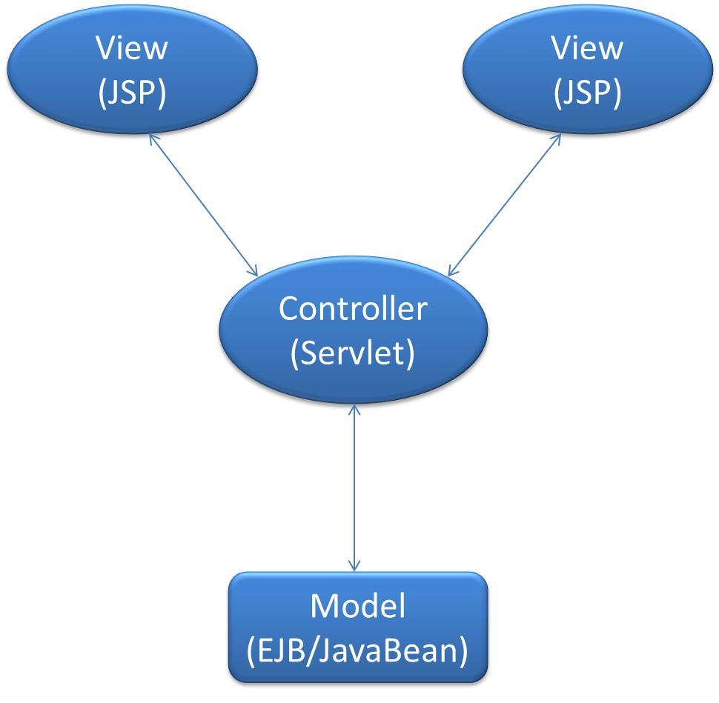

**Figure : Interaction between the components of the MVC pattern**

1. Data Access Object(DAO): The DAO pattern encapsulates data access logic from the business logic of a J2EE application. Typically, a component of a J2EE application that handles the business logic with the data access logic changes if any change occurs in the underlying data source. By using, the DAO pattern, a data access object that handles the data access logic for the application can be implemented. The following figure shows the DAO pattern:

# 

# Figure : The DAO Design Pattern

.

**4.3. DATABASE PROCEDURAL DESIGN**

Also known as component-level design, it occurs after data, architectural, and interface designs have been established. The intent is to translate the design model into operational software. Here we study about the modules which constitute our system.

4.3.1 MODULE DESCRIPTION:-

There are four modules in my system these are:

1. ADMINISTRATOR:-

In Administrator module we have five options

* Check Mail.
* Send Mail.
* View User.
* Search User.
* Delete User.
* When the administrator selects the “Send Mail” option, then the form will be opened for sending mail. Then, the admin send mail to any other user who has user id in the organization.
* In “Check Mail” option, the admin check for the mails. If the user has any mails, then the mails will be displayed. He will check the mail and delete the unnecessary mails. If the user has mails the message “No Mails” will be displayed.
* When the admin select the “View User” option, then the no. of users who currently are using the system are displayed.
* When the administrator selects the option “Search User”, he will search the existing user, if any.
* When the administrator select the option “Delete User” , he will delete an existing user, if any.

1. User:-

In user module we have six options.

1. Send Mail.
2. Check Mail.
3. Generate Contact.
4. Delete Contact.
5. View Contact.
6. Search Contact.

* When the user selects the “Send Mail” option, then the form will be opened for sending mail. Then the user can send mail to any user who has a user id in the organization.
* In “Check Mail” option, the user can check for the mails, if the user has any mails. The mails are displayed. He will check the mails and can delete the unnecessary mails. If the user has no mails then the message “No Mails” will be displayed.
* When the User selects the option “Generate Contact”, he will generate a new Contact, if any.
* When the administrator selects the option “Delete Contact”, he will delete an existing user, if any.
* When the administrator selects the option “Search Contact”, he will search an existing user, if any.
* When the user select the “View Contact” option, then the no. of contacts that are added, are displayed.

.

1. REGISTRATION-

This module is responsible for capturing and submitting the details of all the employee of the System so that they can get the facility of mail, chat, search etc

1. FEED BACK PROCESS:-

This module provides the admin wit an opportunity of introspection based on the feedback of the users he can modify the site accordingly. On the other hand users also get a feedback reply from the admin pointing out that their feedback has been acknowledged

1. LOGIN:-

In this module User enter the User id and password is checked andonly valid user id and password will get entry into member’s zone. This is a security feature to avoid entry of unauthorized users

1. WRITE MAIL:-

You can write any mail and also attach any document or image and send to your destinations. You can write any mail and also attach any document or image and send to your destinations.

1. CHAT:-

This is very beneficial to convey message by chating by using this we can save time a lot.

This is available for all the registered user.

1. MAIL INBOX:-

User and admin can check their mail and also download the attachment files with their mail box.

1. SECURITY MANAGEMENT PROCESS:-

This module provides functionality to change the user id and the password.

1. LOGOUT:-

The Admin and user can successfully logout and their session will be destroyed.

1. Help:-

Provide the functionality to get help about the any query.

**4.4. USER INTERFACE DESIGN**

User interface design focus on the user's experience and interaction. The goal of user interface design is to make the user's interaction as simple and efficient as possible.

The following characteristics are considered during the user interface design:

* Easy to use.
* Easy to learn.
* Easy to navigate.
* Intuitive.
* Consistent.
* Efficient.
* Error-free.
* Functional.

As we know Virtual shopping mall is a web based application, so in order to design the interface we have used the following technologies:

* HTML
* CSS
* JavaScript, etc

Some of the design components are as follows:

* Single-Line Text Input

This control permits the users to entry of any character data. Text input controls accept a string value and contribute it to the form data set.

* Multi-Line Text Input

This control permits the users to enter multiple lines of text.

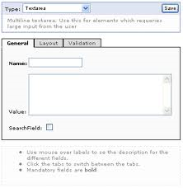

* Password Text Input

This control permits the user to enter the sensitive data, such as a password, that could be harmful to display on the screen where someone could "shoulder surf," or covertly observe, and thus compromise security measures

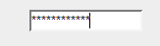

* Submit and Reset

These controls are similar to buttons, these controls are used to send the data to server and clear the form respectively.

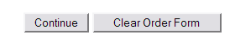

* Buttons

This control is generally used to invoke a call in a scripting language.

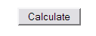

* Radio Buttons

This control requires that a single option always be selected, and thus is almost always used as a group of controls with the same name. A group of radio buttons provides a single value representing the current selection to the form data set.

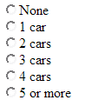

* Checkboxes

This simple on/off control has become familiar to computer users everywhere. Often, this control is used in a group which uses the same name, which allows for a select-zero-or-more behavior

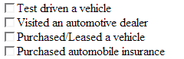

* Single-Select Menus

This control enforces a single selection out of several options.

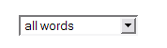

* Multiple-Select Menus

This control enables to accept multiple selections, or even to select nothing at all.

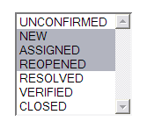

* File Select

This control is used to upload any files on server.

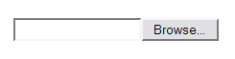

The user interface is arguably the most important element of a computer based system or product. The user interface of a webApp is its “First Impression”. Regardless of the value of its content, the sophistication of its processing capabilities and services. and the overall benefit of the webapp itself. The interface must “grab” a potential user immediately.

A well-designed interface improves the user’s perception of the content or services provided by the site. An interface design should be user friendly by which any user can access the site easily and can go anywhere on the site and collect the information related to its own need. This design begins with the identification of user, task and environmental requirements once user tasks have been identified; user scenarios are created and analyzed to define a set of interface objects and actions.

The interface design concepts, principles and methods are all applicable to the design of user interfaces for web application

Nielsen and Wagner [NIE96] suggest a few simple guidelines based on their redesign of a major WebApp, which I also consider to design my project. I considered the following aspects while designing the web application:

1. User tends to get annoyed with various error generated during surfing any site. These errors include server errors and other minor ones. These errors are likely to cause a user to leave the Web site and look elsewhere for information or services.

I have taken appropriate measures to check these errors.

1. User wants to view graphics rather than reading text because reading speed on a computer monitor is approximately 25 percent slower than reading speed for hard copy. Therfore, I have used ample amount of graphics which will not force the user to read voluminous amount of text.
2. User prefers to view the whole information with using much of mouse. So I have designed the page within the dimensions of a typical browser window. This will avoid the much scrolling of the pages, which annoys the user.
3. Navigation is a very important component of any web application. So I have considered this aspect very carefully. I have kept the navigation option very obvious, so that even a causal user find it very easy. The user will not have to search the screen to determine how to link to other content or services.

5. Above all I have maintained the aesthetics of the whole site so that it should not be superseded by the functionality

**5.1.COMPLETE PROJECT CODING**

**Welcome.jsp**

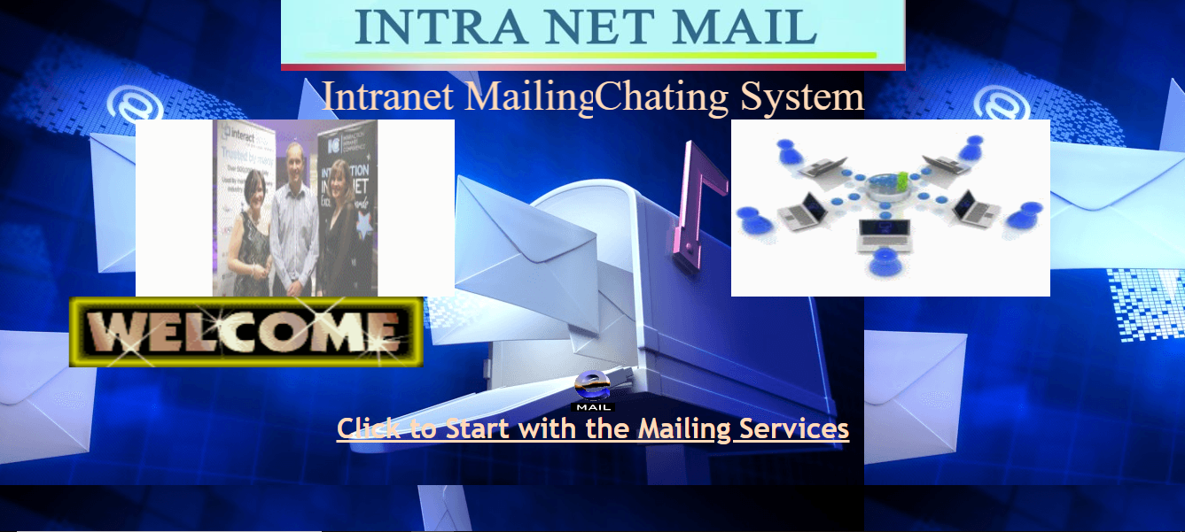

<html>

<head><title>Welcome To chating </title>

<meta name=*"Microsoft Theme"* content=*"copy-of-industrial 011"*>

</head>

<body bgcolor=*#FFFFFF* leftmargin=*0* Topmargin=*0* background=*"Email.png"* text=*"#BC5461"* link=*"BC54FF"* vlink=*"#FF54FF"* alink=*"#FF5400"*>

<table align=*"center"* cellpadding=*"0"* cellspacing=*"0"*>

<center><img border=*"0"* src=*"Images/IMS.JPG"* width=*"705"* height=*"82"*>

<td colspan=*"2"*></td>

</tr>

<tr>

<td align=*"center"*>

<marquee direction=*"right"* behavior=*"scroll"* ><font color=*" peachpuff"* size=*"8"*> Intranet Mailing System</font></marquee>

<img border=*"0"* src=*"Images/emp.gif"* width=*"360"* height=*"200"* align=*"top"*/>

</td>

<td align=*"center"*>

<marquee direction=*"left"* behavior=*"scroll"*><font color=*"peachpuff"* size=*"8"*>Intranet Chating System</font></marquee>

<img border=*"0"* src=*"Images/ims.gif"* width=*"360"* height=*"200"* align=*"top"*/>

</td>

</tr>

<tr>

<td align=*"center"* colspan=*"2"*>

<marquee behavior=*"alternate"*><img src=*"Images/WEL2.GIF"* width=*"400"* height=*"80"* align=*"middle"*/></marquee>

</td>

</tr>

<tr>

<td align=*"center"* colspan=*"2"*>

<img src=*"Images/EMAIL.GIF"* border=*0* width=*"50"* height=*"50"*>

</td>

</tr>

<tr>

<td align=*"center"* colspan=*"2"*>

<h1><font face=*"Trebuchet MS, Arial, Helvetica"* color=*"#BC7B54"*><u><a href=*"loginsc.jsp"*><font size=*"6"* color=*" peachpuff"*>Click

to Start with the </font><font size=*"6"* color=*" peachpuff"*>Mailing Services</font></a></u></font></h1>

</td>

</tr>

</table>

</body>

</html>

**Signmeup.jsp**

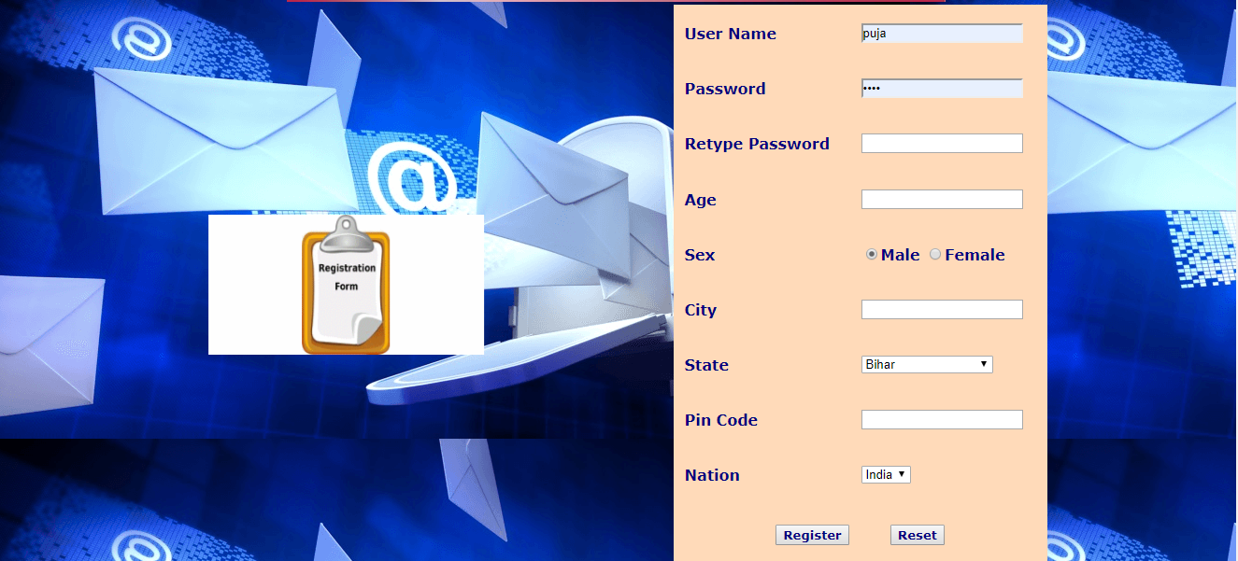

<html>

<head><title>Welcome to College Mailing Chatting System</title>

<script>

**function** check()

{

**var** u=window.document.signmeup.uname.value;

**var** p=window.document.signmeup.pwd.value;

**var** newp=window.document.signmeup.pwd1.value;

**var** a=window.document.signmeup.age.value;

**var** pi=window.document.signmeup.pin.value;

**var** c=window.document.signmeup.city.value;

**if**(u=="")

{

alert("Please enter the username");

window.document.signmeup.uname.focus();

}

**else** **if**(!isNaN(u))

{

alert("Please enter the name in characters");

document.signmeup.uname.focus();

}

**else** **if**(p=="")

{

alert("Please enter the pass word");

window.document.signmeup.pwd.focus();

}

**else** **if**(!isNaN(p))

{

alert("Please enter the password in characters");

document.signmeup.pwd.focus();

}

**else** **if**(a=="")

{

alert("Please enter the age column");

window.document.signmeup.age.focus();

}

**else** **if**(isNaN(a))

{

alert("Please enter the age in numbers");

document.signmeup.age.focus();

}

**else** **if** (isNaN(a) || a< 18 || a>100)

{

alert("The age must be a number between 18 and 100");

}

**if**(c=="")

{

alert("Please enter the city");

window.document.signmeup.uname.focus();

}

**else** **if**(!isNaN(c))

{

alert("Please enter the city in characters");

document.signmeup.uname.focus();

}

**else** **if**(pi=="")

{

alert("Please enter the pincode ");

window.document.signmeup.pin.focus();

}

**else** **if**(isNaN(pi))

{

alert("Please enter the pincode in numbers");

document.signmeup.pin.focus();

}

**else** **if**(p!=newp)

{

alert("Password Doesn't match");

document.signmeup.pwd.value="";

document.signmeup.pwd1.value="";

document.signmeup.pwd.focus();

}

**else**

document.signmeup.submit();

}

</script>

<meta name=*"Microsoft Theme"* content=*"copy-of-industrial 011"*>

</head>

<body leftmargin=*0* Topmargin=*0* bgcolor=*#FFFFFF* text=*#BC5461* background=*"Email.png"* link=*"#BC54FF"* vlink=*"#FF54FF"* alink=*"#FF5400"*> <font size=*+2* >

<body leftmargin=*0* Topmargin=*0* bgcolor=*"#a9a9a9"* text=*#BC5461* link=*"#BC54FF"* vlink=*"#FF54FF"* alink=*"#FF5400"*> <font size=*+2* >

<blink>

<center>

</center>

</blink>

<center><img border=*"0"* src=*"Images/IMS.JPG"* width=*"705"* height=*"82"*>

<table width=*"70%"* height=*"100%"* align=*"center"*>

<tr>

<td width=*"43%"* align=*"justify"*>

<marquee direction=*"right"* behavior=*"alternate"*>

<img alt=*"Register yourself"* src=*"Images/reg.gif"* width=*"295"* height=*"150"*>

</marquee>

</td>

<td>

<form method=*post* name=*signmeup* action=*"Serv_SignMeUp"*>

<!--Strat Table tag-->

<table cellpadding=*10* bgcolor=*"peachpuff"* width=*"400"* height=*"600"* align=*"right"*>

<tr>

<td>

<font face=*"Verdana"* color=*"#000080"*><b>User Name</b></font>

</td>

<td>

<font face=*"Verdana"* color=*"#000080"*><b><input type =*text* name =*uname* value=*""* ></b></font>

</td>

</tr>

<tr>

<td>

<font face=*"Verdana"* color=*"#000080"*><b>Password&nbsp;</b></font>

</td>

<td>

<font face=*"Verdana"* color=*"#000080"*><b><input type =*password* name =*pwd* value=*""* ></b></font>

</td>

</tr>

<tr>

<td>

<font face=*"Verdana"* color=*"#000080"*><b>Retype Password</b></font>

</td>

<td>

<font face=*"Verdana"* color=*"#000080"*><b><input type =*password* name =*pwd1* value=*""* ></b></font>

</td>

</tr>

<tr>

<td>

<font face=*"Verdana"* color=*"#000080"*><b>Age</b></font>

</td>

<td>

<font face=*"Verdana"* color=*"#000080"*><b><input type =*text* name=*age*></b></font>

</td>

</tr>

<tr>

<td>

<font face=*"Verdana"* color=*"#000080"*><b> Sex</b></font>

</td>

<td>

<font face=*"Verdana"* color=*"#000080"*><b><input type =*radio* name =*r1* value=*Male* checked >Male

<input type =*radio* name =*r1* value=*Female*>Female</b></font>

</td>

</tr>

<tr>

<td>

<font face=*"Verdana"* color=*"#000080"*><b>City</b></font>

</td>

<td>

<font face=*"Verdana"* color=*"#000080"*><b><input type =*text* name=*city*></b></font>

</td>

</tr>

<tr>

<td>

<font face=*"Verdana"* color=*"#000080"*><b> State&nbsp;</b></font>

</td>

<td>

<select name=*state*>

<option value=*"ND"*> new Delhi</option>

<option value=*"BR"*selected> Bihar</option>

<option value=*"JH"*> Jharkhand</option>

<option value=*"AP"*> Andhra Pradesh</option>

<option value=*"SK"* > sikkim</option>

<option value=*"PB"*> Punjab</option>

<option value=*"HR"*> Hariyana</option>

<option value=*"HP"*> Himanchal Pradesh</option>

<option value=*"GJ"*> Gujrat</option>

<option value=*"MP"*> Madhya Pradesh</option>

<option value=*"JK"*> jammu kashmir</option>

<option value=*"MH"*> Maharashtra</option>

<option value=*"RJ"*> Rajasthan</option>

<option value=*"KA"*> Karnatka</option>

<option value=*"KR"*> Kerala</option>

<option value=*"UP"*> Uttar Pradesh</option>

</select>

</td>

</tr>

<tr>

<td>

<font face=*"Verdana"* color=*"#000080"*><b>Pin Code&nbsp;</b></font>

</td>

<td>

<input type =*text* name =*pin* maxlength=*6* value=*""* >

</td>

</tr>

<tr>

<td>

<font face=*"Verdana"* color=*"#000080"*><b> Nation&nbsp;</b></font>

</td>

<td>

<select name=*nation*>

<option selected> India</option>

</select>

</td>

</tr>

<tr>

<td colspan=*"2"* align=*"center"*>

<font size=*"2"* color=*"#000080"*>

<input type =*Button* name =*regis* value=*"Register"* onClick="check()" style="color: *#000080*; font-family: *Verdana*; font-weight: *bold*">&nbsp;&nbsp;

&nbsp;&nbsp;&nbsp;&nbsp;

</font>

<font size=*+2* >&nbsp;&nbsp; <input type =*Reset* name =*reset* value=*"Reset"* style="color: *#000080*; font-family: *Verdana*; font-weight: *bold*"></font>

</td>

</tr>

</table>

<!--Closing Table tag-->

</form>

</td>

</tr>

<table>

</body>

</html>

**Loginsc.jsp:-**

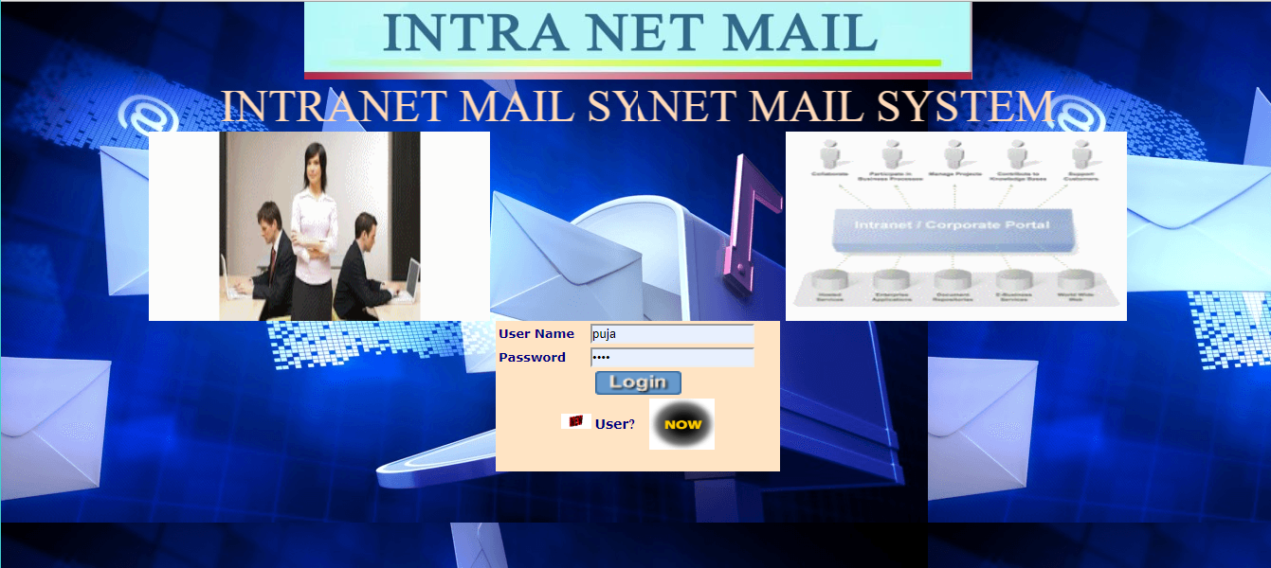

<html>

<head><title>Welcome to College Mailing Chatting System</title>

<script>

**function** check()

{

**var** u=window.document.signmeup.uname.value;

**var** p=window.document.signmeup.pwd.value;

**var** newp=window.document.signmeup.pwd1.value;

**var** a=window.document.signmeup.age.value;

**var** pi=window.document.signmeup.pin.value;

**var** c=window.document.signmeup.city.value;

**if**(u=="")

{

alert("Please enter the username");

window.document.signmeup.uname.focus();

}

**else** **if**(!isNaN(u))

{

alert("Please enter the name in characters");

document.signmeup.uname.focus();

}

**else** **if**(p=="")

{

alert("Please enter the pass word");

window.document.signmeup.pwd.focus();

}

**else** **if**(!isNaN(p))

{

alert("Please enter the password in characters");

document.signmeup.pwd.focus();

}

**else** **if**(a=="")

{

alert("Please enter the age column");

window.document.signmeup.age.focus();

}

**else** **if**(isNaN(a))

{

alert("Please enter the age in numbers");

document.signmeup.age.focus();

}

**else** **if** (isNaN(a) || a< 18 || a>100)

{

alert("The age must be a number between 18 and 100");

}

**if**(c=="")

{

alert("Please enter the city");

window.document.signmeup.uname.focus();

}

**else** **if**(!isNaN(c))

{

alert("Please enter the city in characters");

document.signmeup.uname.focus();

}

**else** **if**(pi=="")

{

alert("Please enter the pincode ");

window.document.signmeup.pin.focus();

}

**else** **if**(isNaN(pi))

{

alert("Please enter the pincode in numbers");

document.signmeup.pin.focus();

}

**else** **if**(p!=newp)

{

alert("Password Doesn't match");

document.signmeup.pwd.value="";

document.signmeup.pwd1.value="";

document.signmeup.pwd.focus();

}

**else**

document.signmeup.submit();

}

</script>

<meta name=*"Microsoft Theme"* content=*"copy-of-industrial 011"*>

</head>

<body leftmargin=*0* Topmargin=*0* bgcolor=*#FFFFFF* text=*#BC5461* background=*"Email.png"* link=*"#BC54FF"* vlink=*"#FF54FF"* alink=*"#FF5400"*> <font size=*+2* >

<body leftmargin=*0* Topmargin=*0* bgcolor=*"#a9a9a9"* text=*#BC5461* link=*"#BC54FF"* vlink=*"#FF54FF"* alink=*"#FF5400"*> <font size=*+2* >

<blink>

<center>

</center>

</blink>

<center><img border=*"0"* src=*"Images/IMS.JPG"* width=*"705"* height=*"82"*>

<table width=*"70%"* height=*"100%"* align=*"center"*>

<tr>

<td width=*"43%"* align=*"justify"*>

<marquee direction=*"right"* behavior=*"alternate"*>

<img alt=*"Register yourself"* src=*"Images/reg.gif"* width=*"295"* height=*"150"*>

</marquee>

</td>

<td>

<form method=*post* name=*signmeup* action=*"Serv_SignMeUp"*>

<!--Strat Table tag-->

<table cellpadding=*10* bgcolor=*"peachpuff"* width=*"400"* height=*"600"* align=*"right"*>

<tr>

<td>

<font face=*"Verdana"* color=*"#000080"*><b>User Name</b></font>

</td>

<td>

<font face=*"Verdana"* color=*"#000080"*><b><input type =*text* name =*uname* value=*""* ></b></font>

</td>

</tr>

<tr>

<td>

<font face=*"Verdana"* color=*"#000080"*><b>Password&nbsp;</b></font>

</td>

<td>

<font face=*"Verdana"* color=*"#000080"*><b><input type =*password* name =*pwd* value=*""* ></b></font>

</td>

</tr>

<tr>

<td>

<font face=*"Verdana"* color=*"#000080"*><b>Retype Password</b></font>

</td>

<td>

<font face=*"Verdana"* color=*"#000080"*><b><input type =*password* name =*pwd1* value=*""* ></b></font>

</td>

</tr>

<tr>

<td>

<font face=*"Verdana"* color=*"#000080"*><b>Age</b></font>

</td>

<td>

<font face=*"Verdana"* color=*"#000080"*><b><input type =*text* name=*age*></b></font>

</td>

</tr>

<tr>

<td>

<font face=*"Verdana"* color=*"#000080"*><b> Sex</b></font>

</td>

<td>

<font face=*"Verdana"* color=*"#000080"*><b><input type =*radio* name =*r1* value=*Male* checked >Male

<input type =*radio* name =*r1* value=*Female*>Female</b></font>

</td>

</tr>

<tr>

<td>

<font face=*"Verdana"* color=*"#000080"*><b>City</b></font>

</td>

<td>

<font face=*"Verdana"* color=*"#000080"*><b><input type =*text* name=*city*></b></font>

</td>

</tr>

<tr>

<td>

<font face=*"Verdana"* color=*"#000080"*><b> State&nbsp;</b></font>

</td>

<td>

<select name=*state*>

<option value=*"ND"*> new Delhi</option>

<option value=*"BR"*selected> Bihar</option>

<option value=*"JH"*> Jharkhand</option>

<option value=*"AP"*> Andhra Pradesh</option>

<option value=*"SK"* > sikkim</option>

<option value=*"PB"*> Punjab</option>

<option value=*"HR"*> Hariyana</option>

<option value=*"HP"*> Himanchal Pradesh</option>

<option value=*"GJ"*> Gujrat</option>

<option value=*"MP"*> Madhya Pradesh</option>

<option value=*"JK"*> jammu kashmir</option>

<option value=*"MH"*> Maharashtra</option>

<option value=*"RJ"*> Rajasthan</option>

<option value=*"KA"*> Karnatka</option>

<option value=*"KR"*> Kerala</option>

<option value=*"UP"*> Uttar Pradesh</option>

</select>

</td>

</tr>

<tr>

<td>

<font face=*"Verdana"* color=*"#000080"*><b>Pin Code&nbsp;</b></font>

</td>

<td>

<input type =*text* name =*pin* maxlength=*6* value=*""* >

</td>

</tr>

<tr>

<td>

<font face=*"Verdana"* color=*"#000080"*><b> Nation&nbsp;</b></font>

</td>

<td>

<select name=*nation*>

<option selected> India</option>

</select>

</td>

</tr>

<tr>

<td colspan=*"2"* align=*"center"*>

<font size=*"2"* color=*"#000080"*>

<input type =*Button* name =*regis* value=*"Register"* onClick="check()" style="color: *#000080*; font-family: *Verdana*; font-weight: *bold*">&nbsp;&nbsp;

&nbsp;&nbsp;&nbsp;&nbsp;

</font>

<font size=*+2* >&nbsp;&nbsp; <input type =*Reset* name =*reset* value=*"Reset"* style="color: *#000080*; font-family: *Verdana*; font-weight: *bold*"></font>

</td>

</tr>

</table>

<!--Closing Table tag-->

</form>

</td>

</tr>

<table>

</body>

</html>

**Listoption.jsp:-** 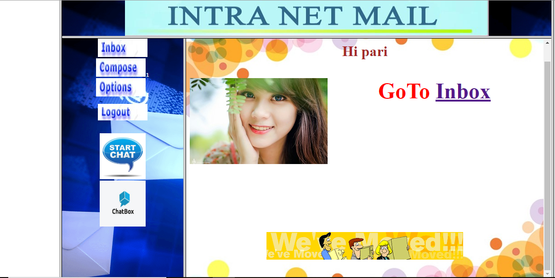

<HTML>

<HEAD><TITLE>Welcome to Intranet Mailing System</title></head>

<frameset cols=*"10,80,10"*>

<frame src=*""*>

<frameset rows=*"13,87"*>

<frame src=*"Intramain.jsp"* scrolling=*"no"*>

<frameset cols=*"20,60"*>

<frame src=*"Serv_List"* name=*in1* scrolling=*"no"*>

<frame src=*"description"* name=*in2*>

</frameset>

</frameset>

</frameset>

</html>

*Intramain.jsp*

<html>

<head>

<meta http-equiv=*"Content-Type"* content=*"text/html; charset=windows-1252"*>

<meta name=*"GENERATOR"* content=*"Microsoft FrontPage 4.0"*>

<meta name=*"ProgId"* content=*"FrontPage.Editor.Document"*>

<title>New Page 2</title>

</head>

<body leftmargin=*0* Topmargin=*0* background=*"Email.png"*>

<p align=*"center"*><img border=*"0"* src=*"Images/IMS.JPG"* width=*"792"* height=*"85"*></p>

</body>

</html>

import java.io.IOException;

import java.sql.Connection;

import java.sql.SQLException;

import java.sql.Statement;

import javax.servlet.*;

import javax.servlet.http.*;

import connect.ConnectionProvider;

public class Serv_List extends HttpServlet

{

public Serv_List()

{

scon = null;

newfol = null;

f1 = null;

uname = null;

sub = null;

from = null;

date1 = null;

folder = null;

}

public void init()

{

con = ConnectionProvider.getConnection();

try {

st=con.createStatement();

} catch (SQLException e) {

// TODO Auto-generated catch block

e.printStackTrace();

}

}

public void service(HttpServletRequest httpservletrequest, HttpServletResponse httpservletresponse)

throws ServletException, IOException

{

try

{ //st.executeQuery("delete from message");

scon = getServletContext();

HttpSession httpsession = httpservletrequest.getSession(true);

uname = httpsession.getValue("name").toString();

// uname=(String) httpsession.getAttribute("uname");

httpsession.setAttribute("uname", uname);

ServletOutputStream servletoutputstream = httpservletresponse.getOutputStream();

servletoutputstream.println("<html><head><title>Welcome To Intranet Mailing System</title><!--mstheme--><link rel=stylesheet href='copy1111.css'>");

servletoutputstream.println("<meta name=Microsoft Theme content=copy-of-industrial 1111>");

servletoutputstream.println("</head><body leftmargin=0 background='Email.png' Topmargin=0><!--table cellpadding=16 align=center-->");

servletoutputstream.println("<center><pre><i><b><a href=Serv_Inbox target=in2><img src='ims%20images/INBOX.JPG' border=0 width=108 height=40></a>");

servletoutputstream.println("<a href=Serv_Compose target=in2><img src='ims%20images/COMPOSE.JPG' border=0 width=108 height=40></a></b></i><font color=#FFFFFF>1</font><i><b>");

servletoutputstream.println("<a href=Serv_Option target=in2><img src='ims%20images/Options.jpg' border=0 width=108 height=40 lowsrc=Images%20Raj/Options.jpg></a><font color=#FFFFFF>1</font>");

servletoutputstream.println("<pre><i><b><a href=Serv_Logout target=_parent><img src='ims%20images/Logout.jpg' border=0 width=108 height=36></a></b></i></pre><center>");

servletoutputstream.println("<a href=Serv_C1 target=in1><img src='ims%20images/startchat.jpg' border=0 width=100 height=100></a>");

servletoutputstream.println("<a href=Serv_C target=in2><img src='ims%20images/chatbox.jpg' border=0 width=100 height=100></a>");

}

catch(Exception exception)

{

exception.printStackTrace();

}

}

ServletContext scon;

String newfol;

String f1;

String uname;

String sub;

String from;

String date1;

String folder;

Connection con;

Statement st;

}

Description:-

import java.io.IOException;

import java.io.PrintWriter;

import javax.servlet.ServletException;

import javax.servlet.http.*;

public class description extends HttpServlet

{

public description()

{

}

public void service(HttpServletRequest httpservletrequest, HttpServletResponse httpservletresponse)

throws IOException, ServletException

{

PrintWriter printwriter = httpservletresponse.getWriter();

httpservletresponse.setContentType("Text/Html");

HttpSession httpsession = httpservletrequest.getSession(true);

String s = httpsession.getValue("name").toString();

printwriter.println("<html>");

printwriter.println("<body background='dii.jpg' text=blue width='70%' align='center'>");

printwriter.println("<br>");

printwriter.println("<center><h1><font color=brown> Hi " + s + "<h2><font color=blue>");

printwriter.println("<img src='Images/"+s+".jpg' align='left' border=0>");

printwriter.println("<font color=red>GoTo <a href='Serv_Inbox'> Inbox</a>");

printwriter.println("<h2><b><i></i></b></h2><br><br><br><br>");

printwriter.println("<img src='Images/MOVED.GIF' border=0>");

printwriter.println("</body></html>");

}

}

**INBOX:-**

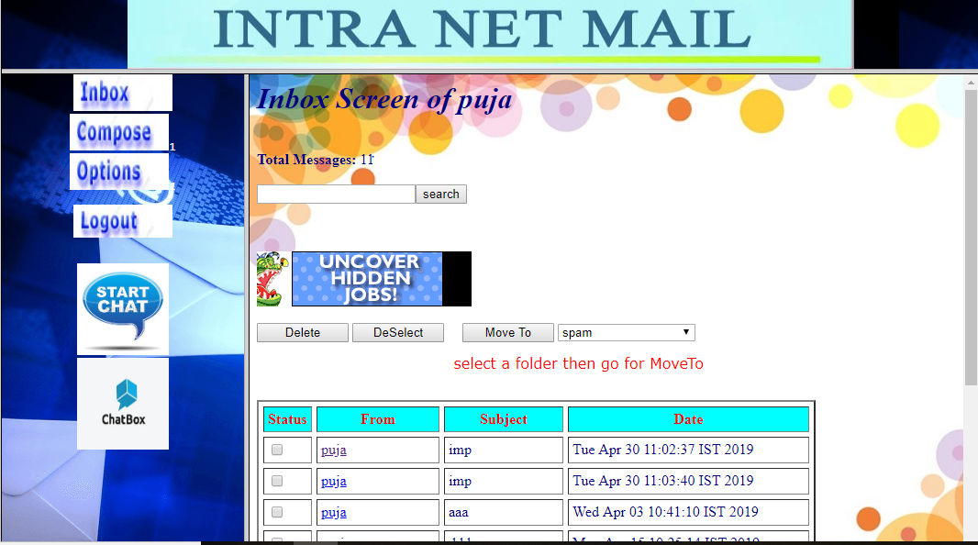

import java.io.IOException;

import java.sql.*;

import javax.servlet.*;

import javax.servlet.http.*;

import connect.ConnectionProvider;

public class Serv_Inbox extends HttpServlet

{

public Serv_Inbox()

{

st = null;

st1 = null;

con = null;

scon = null;

rs = null;

rs1 = null;

newfol = null;

f1 = null;

uname = null;

sub = null;

from = null;

date1 = null;

}

public void service(HttpServletRequest httpservletrequest, HttpServletResponse httpservletresponse)

throws ServletException, IOException

{

try

{

// Class.forName("oracle.jdbc.driver.OracleDriver");

// con = DriverManager.getConnection("jdbc:oracle:thin:@localhost:1521:xe", "system", "ojasvi");

con=ConnectionProvider.getConnection();

st = con.createStatement();

scon = getServletContext();

HttpSession httpsession = httpservletrequest.getSession(true);

uname = httpsession.getValue("name").toString();

ServletOutputStream servletoutputstream = httpservletresponse.getOutputStream();

servletoutputstream.println("<html><head><title>Welcome To Intranet Mailing System</title>");

servletoutputstream.println("<script>function d()");

servletoutputstream.println("{document.f.action='Serv_DeleteCkd';");

servletoutputstream.println("document.f.submit();}");

servletoutputstream.println("function e()");

servletoutputstream.println("{document.f.action='Serv_Enter';");

servletoutputstream.println("document.f.submit();}");

servletoutputstream.println("</script></head>");

servletoutputstream.println("<body bgcolor=white background='dii.jpg' text=navy>");

servletoutputstream.println("<blink><h1><b><i>Inbox Screen of " + uname + " </i></b></h1></blink><br>");

int i = 0;

for(ResultSet resultset = st.executeQuery("select mailid from newcompose where mailto='" + uname + "' and folder='inbox'"); resultset.next();)

i++;

servletoutputstream.println("<b>Total Messages: </b> " + i + "<br><br>");

servletoutputstream.println("<br><a href='http://www.monsterindia.com' target=new><img src='jobsearch1.gif' border=0></a><br><br>");

servletoutputstream.println("<form name=f action='Serv_MoveFolder'>");

servletoutputstream.println("<input type=button name=delete value='Delete' onClick='d()' style=\"width:100\">");

servletoutputstream.println("<input type=reset name=deselect value='DeSelect' style=\"width:100\">");

servletoutputstream.println("&nbsp;&nbsp;&nbsp;&nbsp;<input type=submit name=move value='Move To' style=\"width:100\">");

ResultSet resultset1 = st.executeQuery("select folder from folders where uname='" + uname + "'");

servletoutputstream.println("<select name=se style=\"width:150\">");

for(; resultset1.next(); servletoutputstream.println("<option value=" + f1 + ">" + f1 + "</option>"))

f1 = resultset1.getString(1);

servletoutputstream.println("</select><br>");

servletoutputstream.println("<pre> <font face=verdana color=red>select a folder then go for MoveTo</font></pre>");

resultset1.close();

st.close();

servletoutputstream.println("<br><table border=2 cellpadding=4 cellspacing=5 width=80%><TR bgcolor=#00FFFF><th><font color=red>Status</th><TH><font color=red>From</TH><TH><font color=red>Subject</Th><TH><font color=red>Date</TH></TR>");

st1 = con.createStatement();

rs1 = st1.executeQuery("select mailid,mailfrom,subject,maildate,mailst from newcompose where mailto='" + uname + "'");

int j = 0;

while(rs1.next())

{

j++;

m = rs1.getInt(1);

from = rs1.getString(2);

sub = rs1.getString(3);

date1 = rs1.getString(4);

sta = rs1.getInt(5);

if(sub == null)

sub = "[NONE]";

if(sta == 1)

{

servletoutputstream.println("<tr><td><center><img src='button.gif' height=20 width=25 ></td><td>");

servletoutputstream.println("<input type=checkbox name=b" + j + " value=" + m + "></td><td><a href='Serv_SeeMessage?id=" + m + "'>" + from + "</td></a><td>" + sub + "</td><td>" + date1 + "</td></tr>");

} else

{

servletoutputstream.println("<tr><td width=6%><input type=checkbox name=b" + j + " value=" + m + "></td><td width=24%><a href='Serv_SeeMessage?id=" + m + "'>" + from + "</td></a><td width=23%>" + sub + "</td><td width=47%>" + date1 + "</td></tr>");

}

}

servletoutputstream.println("<script language=javascript>");

servletoutputstream.println("function chkit(){");

for(int k = 1; k <= j; k++)

servletoutputstream.println("document.f.b" + k + ".checked=document.f.chkall.checked;");

servletoutputstream.println("}</script>");

servletoutputstream.println("<input type=hidden name=hid value=" + j + ">");

servletoutputstream.println("</form>");

servletoutputstream.println("</table></body></html>");

}

catch(Exception exception)

{

exception.printStackTrace();

}

}

Statement st;

Statement st1;

Connection con;

ServletContext scon;

ResultSet rs;

ResultSet rs1;

String newfol;

String f1;

String uname;

String sub;

String from;

String date1;

int sta;

int m;

**}**

**See message:-**

import java.io.IOException;

import java.io.PrintStream;

import java.sql.*;

import javax.servlet.*;

import javax.servlet.http.*;

import connect.ConnectionProvider;

public class Serv_SeeMessage extends HttpServlet

{

public Serv_SeeMessage()

{

st = null;

st1 = null;

rs = null;

con = null;

scon = null;

}

public void service(HttpServletRequest httpservletrequest, HttpServletResponse httpservletresponse)

throws ServletException, IOException

{

try

{

//Class.forName("oracle.jdbc.driver.OracleDriver");

//con = DriverManager.getConnection("jdbc:oracle:thin:@localhost:1521:xe", "system", "ojasvi");

con=ConnectionProvider.getConnection();

scon = getServletContext();

HttpSession httpsession = httpservletrequest.getSession(true);

uname = httpsession.getValue("name").toString();

st = con.createStatement();

ServletOutputStream servletoutputstream = httpservletresponse.getOutputStream();

System.out.println("id:" + httpservletrequest.getParameter("id"));

int i = 0;

try

{

i = Integer.parseInt(httpservletrequest.getParameter("id"));

}

catch(Exception exception1) { }

System.out.println("mi:" + i);

for(rs = st.executeQuery("select mailfrom,mailto,subject,maildate,mailcc,mailbcc,maildata,mailst,mailid,mailexch from newcompose where mailto='" + uname + "' and mailid=" + i); rs.next(); servletoutputstream.println("</form></body></html>"))

{

String s = rs.getString(1);

String s1 = rs.getString(2);

String s2 = rs.getString(3);

String s3 = rs.getString(4);

String s4 = rs.getString(5);

String s5 = rs.getString(6);

String s6 = rs.getString(7);

String s10=rs.getString(10);

System.out.println("attacchment got into the serv_seeMass "+s10);

int j = rs.getInt(8);

int k = rs.getInt(9);

servletoutputstream.println("<html><head><title>Welcome to Intranet Mailing System</title></head>");

servletoutputstream.println("<form name=fo>");

servletoutputstream.println("<body bgcolor=white background='INDTEXTB.JPG' text=blue><pre>");

servletoutputstream.println("<img src=adv2.gif>");

servletoutputstream.println("<table cellpadding=15 ><tr><td><a href=Serv_Compose1?from=" + s + " & subj=" + s2 + ">Reply</a>");

servletoutputstream.println("</td><td><a href=Serv_Inbox>Inbox</a></td></tr></table><hr>");

servletoutputstream.println("<pre><br>" + s + " wrote a mail on " + s3 + "<br>");

servletoutputstream.println("<p>" + s6 + "</pre>");

servletoutputstream.println("<hr><table cellpadding=15><tr><td><a href=Serv_Compose1?from=" + s + "&subj=" + s2 + ">Reply</a>");

System.out.println(s10.equals("null"));

if(s10.equals("null"))

{

s10=null;

System.out.println("vale in s10 is set to "+s10);

}

if(s10 != null)

{

servletoutputstream.println("<hr><table cellpadding=15><tr><td><a href=Serv_Download?from=" + s10 + "&subj=" + s2 + "+fname>attachment</a>");

}

servletoutputstream.println("</td><td><a href=Serv_Inbox>Inbox</a></td></tr></table>");

servletoutputstream.println("<center><img src=adv1.gif>");

st1 = con.createStatement();

int l = st1.executeUpdate("update newcompose set mailst=0 where mailid=" + k);

st1.close();

}

}

catch(Exception exception)

{

exception.printStackTrace();

}

}

Statement st;

Statement st1;

ResultSet rs;

Connection con;

ServletContext scon;

String uname;

}

**Serv compose:-**

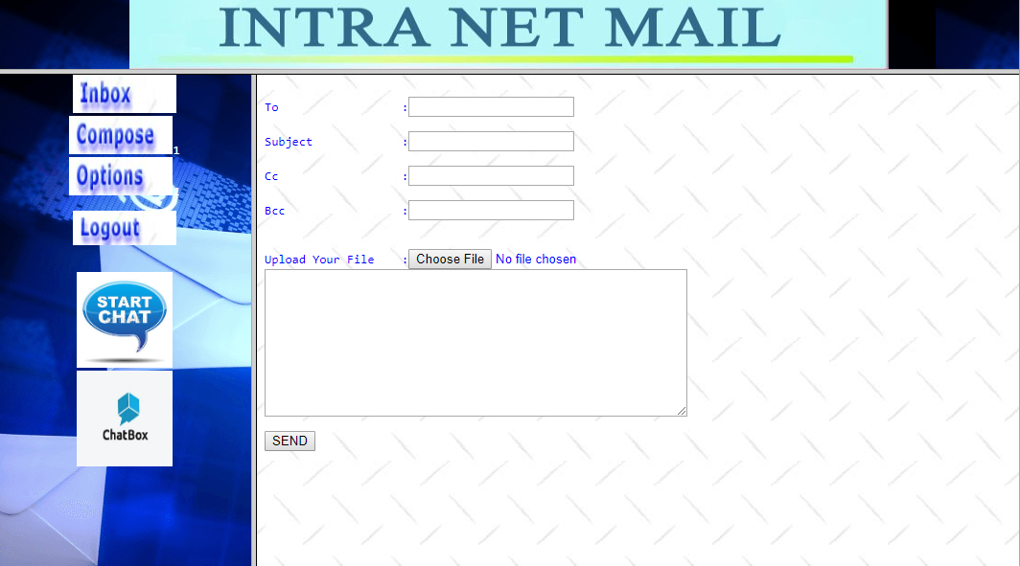

import java.io.IOException;

import java.sql.*;

import javax.servlet.*;

import javax.servlet.http.*;

import connect.ConnectionProvider;

public class Serv_Compose extends HttpServlet

{

public Serv_Compose()

{

con = null;

st = null;

scon = null;

rs = null;

sos = null;

}

public void service(HttpServletRequest httpservletrequest, HttpServletResponse httpservletresponse)

throws ServletException, IOException

{

try

{

// Class.forName("oracle.jdbc.driver.OracleDriver");

// con = DriverManager.getConnection("jdbc:oracle:thin:@localhost:1521:xe", "system", "ojasvi");

con=ConnectionProvider.getConnection();

st = con.createStatement();

scon = getServletContext();

String s = null;

HttpSession httpsession = httpservletrequest.getSession(true);

s = httpsession.getValue("name").toString();

ServletOutputStream servletoutputstream = httpservletresponse.getOutputStream();

servletoutputstream.println("<html><title>Intranet Mailing System</title>");

servletoutputstream.println("<body bgcolor=white background='INDTEXTB.JPG' text=blue><center><img src='Images/ADV3.GIF' border=0></center>");

servletoutputstream.println("<pre>");

servletoutputstream.println("<form name=form4 method=post action='Serv_Send' enctype='multipart/form-data'>");

servletoutputstream.println("To :<input type=text name=to required><br>");

servletoutputstream.println("Subject :<input type=text name=subject value=''><br>");

servletoutputstream.println("Cc :<input type=text name=cc value=''><br>");

servletoutputstream.println("Bcc :<input type=text name=bcc value=''><br><br>");

servletoutputstream.println("Upload Your File :<input type='file' name='file'/>");

servletoutputstream.println("<textarea name=maildata rows=10 cols=60></textarea><br>");

servletoutputstream.println("<input type=submit name=submit1 value='SEND'><br>");

rs = st.executeQuery("select actname,emailid from address where uname='" + s + "'");

if(rs.next())

{

servletoutputstream.println("<SELECT name=se onclick=getName(value) style=\"LEFT: 400px; POSITION: absolute; TOP: 160px; BACKGROUND-COLOR:#b464ff;width:130px;FONT-WEIGHT:BOLD\"");

servletoutputstream.println("SIZE=5 name=List1 value=\"List1\">");

do

servletoutputstream.println("<OPTION value=" + rs.getString(2) + " >" + rs.getString(1) + "</OPTION>");

while(rs.next());

servletoutputstream.println("</SELECT>");

}

servletoutputstream.println("</form></body></html>");

servletoutputstream.println("<script language=javascript>");

servletoutputstream.println("function getName(Myname){");

servletoutputstream.println("document.form4.to.value=Myname");

servletoutputstream.println("}</script>");

}

catch(Exception exception)

{

exception.printStackTrace();

}

}

Connection con;

Statement st;

ServletContext scon;

ResultSet rs;

ServletOutputStream sos;

}

**Serv send:-**

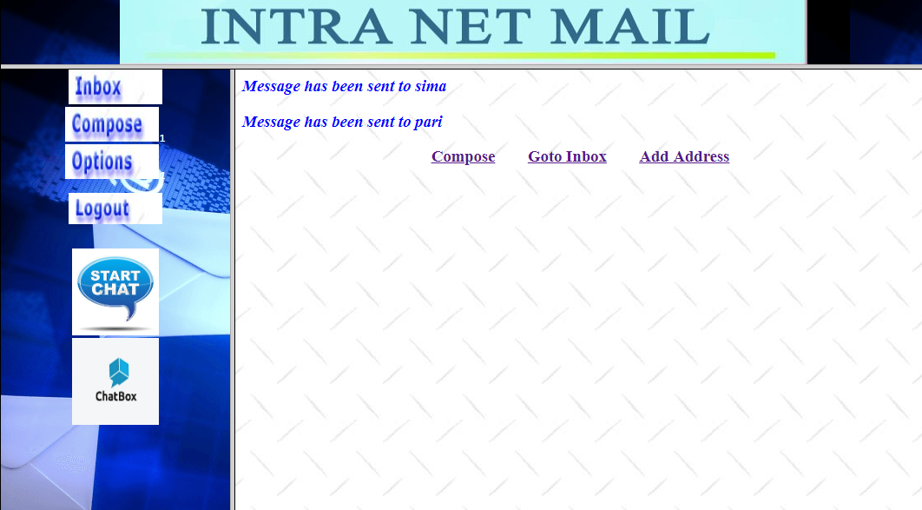

import java.io.IOException;

import java.io.PrintStream;

import java.sql.*;

import java.util.Date;

import java.util.StringTokenizer;

import javax.servlet.*;

import javax.servlet.http.*;

import com.oreilly.servlet.MultipartRequest;

import connect.ConnectionProvider;

public class Serv_Send extends HttpServlet

{

public Serv_Send()

{

stmt = null;

st1 = null;

st2 = null;

st3 = null;

con = null;

rs = null;

rs1 = null;

scon = null;

sos = null;

mfrom = null;

flag = true;

str1 = null;

mdate = "";

}

public void service(HttpServletRequest httpservletrequest, HttpServletResponse httpservletresponse)

throws ServletException, IOException

{

try

{

// Class.forName("oracle.jdbc.driver.OracleDriver");

System.out.println("Driver Loaded");

// con = DriverManager.getConnection("jdbc:oracle:thin:@localhost:1521:xe", "system", "ojasvi");

con=ConnectionProvider.getConnection();

System.out.println("Connection created");

stmt = con.createStatement();

scon = getServletContext();

HttpSession httpsession = httpservletrequest.getSession(true);

mfrom = httpsession.getValue("name").toString();

ServletOutputStream servletoutputstream = httpservletresponse.getOutputStream();

String path=scon.getRealPath("attachment");

MultipartRequest mpr=new MultipartRequest(httpservletrequest,path,500*1024*1024);

System.out.println("File uploaded successffully");

String fname=mpr.getOriginalFileName("file");

path =path+"\\"+fname;

System.out.println("Attached file "+path);

httpsession.setAttribute("attach",fname);

System.out.println("attached file setted into the session");

String s = mpr.getParameter("to");

String s1 = mpr.getParameter("subject");

String s2 = mpr.getParameter("cc");

String s3 = mpr.getParameter("bcc");

String s4 = mpr.getParameter("s1");

String s5 = mpr.getParameter("maildata");

StringTokenizer stringtokenizer = new StringTokenizer(s, ",");

mdate = String.valueOf(new Date());

while(stringtokenizer.hasMoreTokens())

{

str1 = stringtokenizer.nextToken();

st1 = con.createStatement();

rs1 = st1.executeQuery("select * from signupdetails where uname='" + str1 + "'");

if(rs1.next())

{

bool = true;

} else

{

bool = false;

servletoutputstream.println("<html><head><script>{alert('Invalid Mail-to address - He is an unregistered user');window.history.go(-1);}</script></head></html>");

}

rs1.close();

st1.close();

if(bool && flag)

{

rs = stmt.executeQuery("Select max(mailid) from newcompose");

rs.next();

if(rs == null)

{

i = 1;

} else

{

i = rs.getInt(1);

i++;

}

rs.close();

session= httpservletrequest.getSession(false);

mch=(String)session.getAttribute("attach");

System.out.println("name of the file into serv_send>>>>>>>>>>>>>>>>>"+mch);

st2 = con.createStatement();

System.out.println("St2 successful");

int j = st2.executeUpdate("insert into newcompose values(" + i + ",'" + mfrom + "','" + str1 + "','" + s1 + "','" + s2 + "','" + s3 + "','"+mch+"','" + s5 + "','inbox','" + mdate + "',"+ml+")");

if(j > 0)

servletoutputstream.println("<html><body bgcolor=white background='INDTEXTB.JPG' text=blue><font color=blue><h3><i>Message has been sent to " + str1 + " </i></h3></font>");

st2.close();

}

}

str1 = "";

i++;

st3 = con.createStatement();

System.out.println("St3 successful");

int k = st3.executeUpdate("insert into newcompose values(" + i + ",'" + mfrom + "','" + s2 + "','" + s1 + "','','" + s3 + "','"+mch+"','" + s5 + "','inbox','" + mdate + "',"+ml+")");

if(k > 0)

servletoutputstream.println("<html><body bgcolor=white background='INDTEXTB.JPG' text=blue><font color=blue><h3><i>Message has been sent to " + s2 + " </i></h3></font>");

st3.close();

servletoutputstream.println("<form action=Serv_NewAddress><center>");

servletoutputstream.println("<h3><a href=Serv_Compose>Compose</a>&nbsp&nbsp&nbsp&nbsp&nbsp&nbsp&nbsp&nbsp<a href=Serv_Inbox>Goto Inbox</a>&nbsp&nbsp&nbsp&nbsp&nbsp&nbsp&nbsp&nbsp<a href=Serv_NewAddress>Add Address</a>");

servletoutputstream.println("</form></body></html>");

}

catch(Exception exception)

{

exception.printStackTrace();

}

}

int ml=0;

String mch=null;

HttpSession session;

Statement stmt;

Statement st1;

Statement st2;

Statement st3;

Connection con;

ResultSet rs;

ResultSet rs1;

int i;

ServletContext scon;

ServletOutputStream sos;

boolean bool;

String mfrom;

boolean flag;

String str1;

String mdate;

}

**Serv option:-**

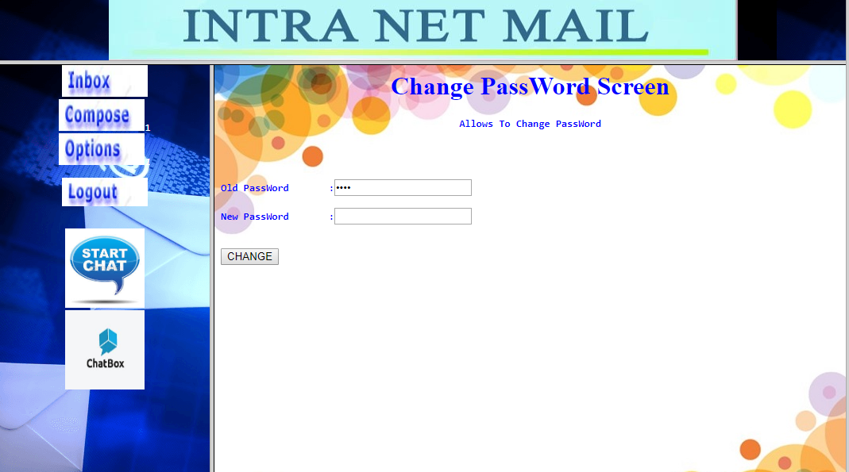

import java.io.IOException;

import java.sql.*;

import javax.servlet.*;

import javax.servlet.http.*;

import connect.ConnectionProvider;

public class Serv_Option extends HttpServlet

{

public Serv_Option()

{

}

public void init(ServletConfig servletconfig)

{

try

{

super.init(servletconfig);

//Class.forName("oracle.jdbc.driver.OracleDriver");

//con = DriverManager.getConnection("jdbc:oracle:thin:@localhost:1521:xe", "system", "ojasvi");

con=ConnectionProvider.getConnection();

st = con.createStatement();

scon = getServletContext();

}

catch(Exception exception)

{

exception.printStackTrace();

}

}

public void service(HttpServletRequest httpservletrequest, HttpServletResponse httpservletresponse)

throws ServletException, IOException

{

try

{

HttpSession httpsession = httpservletrequest.getSession(true);

String s = httpsession.getValue("name").toString();

rs = st.executeQuery("select passwd from signupdetails where uname='" + s + "'");

String s1 = "";

try

{

rs.next();

s1 = rs.getString(1);

}

catch(Exception exception1) { }

ServletOutputStream servletoutputstream = httpservletresponse.getOutputStream();

servletoutputstream.println("<html><head><title>Welcome to Intranet Mailing System></title></head>");

servletoutputstream.println("<body bgcolor=white background='dii.jpg' text=blue><h1><center><blink>Change PassWord Screen</blink></center></h1>");

servletoutputstream.println("<form name=form5 method=post action='Serv_ChangePwd'>");

servletoutputstream.println("<pre><b><h4><center>Allows To Change PassWord</center></h4></b><BR><BR>");

servletoutputstream.println("<b>Old PassWord </b>:<input type=password name=op value=" + s1 + "><br>");

servletoutputstream.println("<b>New PassWord </b> :<input type=password name=np value=''><br><br>");

servletoutputstream.println("<input type=submit name=s3 value='CHANGE'></form></body></HTML>");

}

catch(Exception exception)

{

exception.printStackTrace();

}

}

Statement st;

Connection con;

ResultSet rs;

ServletContext scon;

}

**Change password:-**

import java.io.IOException;

import java.sql.*;

import javax.servlet.*;

import javax.servlet.http.*;

import connect.ConnectionProvider;

public class Serv_ChangePwd extends HttpServlet

{

public Serv_ChangePwd()

{

}

public void init(ServletConfig servletconfig)

{

try

{

super.init(servletconfig);

// Class.forName("oracle.jdbc.driver.OracleDriver");

// con = DriverManager.getConnection("jdbc:oracle:thin:@localhost:1521:xe", "system", "ojasvi");

con=ConnectionProvider.getConnection();

st = con.createStatement();

scon = getServletContext();

}

catch(Exception exception)

{

exception.printStackTrace();

}

}

public void service(HttpServletRequest httpservletrequest, HttpServletResponse httpservletresponse)

throws ServletException, IOException

{

try

{

HttpSession httpsession = httpservletrequest.getSession(true);

un = httpsession.getValue("name").toString();

ServletOutputStream servletoutputstream = httpservletresponse.getOutputStream();

String op = httpservletrequest.getParameter("op");

String s = httpservletrequest.getParameter("np");

int i = st.executeUpdate("Update signupdetails set passwd='" + s + "' where uname='" + un + "' and passwd='"+op+"'");

if(i==1)

{

servletoutputstream.println("<html><body bgcolor=white background='INDTEXTB.JPG' text=blue><h2><i>password is changed</i></h2></body></html>");

httpservletresponse.setHeader("Refresh", "2;URL=Serv_Inbox");

}

else

{

servletoutputstream.println("<html><body bgcolor=white background='INDTEXTB.JPG' text=blue><h2><i>u have enter wrong old password...</i></h2></body></html>");

httpservletresponse.setHeader("Refresh", "2;URL=Serv_Option");

}

}

catch(Exception exception)

{

exception.printStackTrace();

}

}

Statement st;

Connection con;

ResultSet rs;

ServletContext scon;

String un;

}

**Chat room:-**

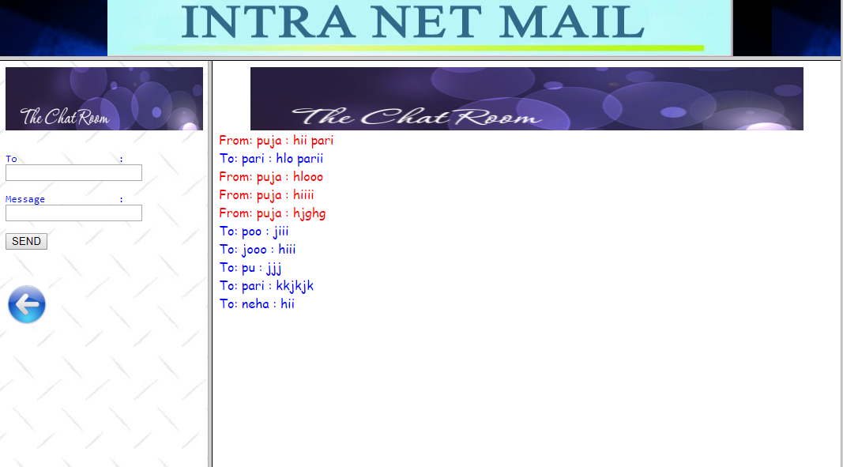

import java.io.IOException;

import java.sql.Connection;

import java.sql.PreparedStatement;

import javax.servlet.ServletContext;

import javax.servlet.ServletException;

import javax.servlet.ServletOutputStream;

import javax.servlet.annotation.WebServlet;

import javax.servlet.http.HttpServlet;

import javax.servlet.http.HttpServletRequest;

import javax.servlet.http.HttpServletResponse;

import javax.servlet.http.HttpSession;

import connect.ConnectionProvider;

/**

* Servlet implementation class Serv_C1

*/

@WebServlet("/Serv_C1")

public class Serv_C1 extends HttpServlet {

private static final long serialVersionUID = 1L;

/**

* @see HttpServlet#HttpServlet()

*/

public Serv_C1() {

super();

// TODO Auto-generated constructor stub

}

/**

* @see HttpServlet#doGet(HttpServletRequest request, HttpServletResponse response)

*/

protected void doGet(HttpServletRequest request, HttpServletResponse response) throws ServletException, IOException {

// TODO Auto-generated method stub

ServletContext sc = request.getServletContext();

try {

ServletOutputStream servletoutputstream = response.getOutputStream();

servletoutputstream.println("<html><title>Intranet Mailing System</title>");

servletoutputstream.println("<body bgcolor=white background='INDTEXTB.JPG' text=blue><center><img src='ims%20images/banner.jpg' border=0 width=250 height=80></center>");

servletoutputstream.println("<pre>");

servletoutputstream.println("<form name=form4 method=get action='Serv_C1'enctype='multipart/form-data'>");

servletoutputstream.println("To :<input type=text name=to value= ''><br>");

servletoutputstream.println("Message :<input type=text name=message value=''><br>");

servletoutputstream.println("<input type=submit name=submit1 value='SEND'><br>");

servletoutputstream.println("<p></p><p></p><p></p><p></p><p></p>");

servletoutputstream.println("<a href=Serv_List target=in1><img src='ims%20images/back.jpg' border=0 width=54 height=54></a>");

HttpSession session = request.getSession();

// synchronized(sc)

// {

Connection con=ConnectionProvider.getConnection();

String to = (String) request.getParameter("to");

String msg = (String) request.getParameter("message");

String from = (String) session.getAttribute("uname");

System.out.println("bfore writing"+con);

try

{

if((msg!=null))

{

PreparedStatement ps=con.prepareStatement("insert into chats values(?,?,?)");

ps.setString(1, from);

ps.setString(2, to);

ps.setString(3, msg);

ps.executeUpdate();

System.out.println("Messages stored");

}

}

catch(Exception e){System.out.println("Unable to store messagesssss");}

System.out.println("Outside storing messages");

ServletContext ct = request.getServletContext();

// }

// session.setAttribute("msg",msg);

// session.setAttribute("from",from);

} catch (IOException e) {

// TODO Auto-generated catch block

System.out.println("Unable to store message");

e.printStackTrace();

}

}

/**

* @see HttpServlet#doPost(HttpServletRequest request, HttpServletResponse response)

*/

protected void doPost(HttpServletRequest request, HttpServletResponse response) throws ServletException, IOException {

// TODO Auto-generated method stub

}

}

**Serv c:-**

import java.io.IOException;

import java.sql.Connection;

import java.sql.PreparedStatement;

import javax.servlet.ServletContext;

import javax.servlet.ServletException;

import javax.servlet.ServletOutputStream;

import javax.servlet.annotation.WebServlet;

import javax.servlet.http.HttpServlet;

import javax.servlet.http.HttpServletRequest;

import javax.servlet.http.HttpServletResponse;

import javax.servlet.http.HttpSession;

import connect.ConnectionProvider;

/**

* Servlet implementation class Serv_C1

*/

@WebServlet("/Serv_C1")

public class Serv_C1 extends HttpServlet {

private static final long serialVersionUID = 1L;

/**

* @see HttpServlet#HttpServlet()

*/

public Serv_C1() {

super();

// TODO Auto-generated constructor stub

}

/**

* @see HttpServlet#doGet(HttpServletRequest request, HttpServletResponse response)

*/

protected void doGet(HttpServletRequest request, HttpServletResponse response) throws ServletException, IOException {

// TODO Auto-generated method stub

ServletContext sc = request.getServletContext();

try {

ServletOutputStream servletoutputstream = response.getOutputStream();

servletoutputstream.println("<html><title>Intranet Mailing System</title>");

servletoutputstream.println("<body bgcolor=white background='INDTEXTB.JPG' text=blue><center><img src='ims%20images/banner.jpg' border=0 width=250 height=80></center>");

servletoutputstream.println("<pre>");

servletoutputstream.println("<form name=form4 method=get action='Serv_C1'enctype='multipart/form-data'>");

servletoutputstream.println("To :<input type=text name=to value= ''><br>");

servletoutputstream.println("Message :<input type=text name=message value=''><br>");

servletoutputstream.println("<input type=submit name=submit1 value='SEND'><br>");

servletoutputstream.println("<p></p><p></p><p></p><p></p><p></p>");

servletoutputstream.println("<a href=Serv_List target=in1><img src='ims%20images/back.jpg' border=0 width=54 height=54></a>");

HttpSession session = request.getSession();

// synchronized(sc)

// {

Connection con=ConnectionProvider.getConnection();

String to = (String) request.getParameter("to");

String msg = (String) request.getParameter("message");

String from = (String) session.getAttribute("uname");

System.out.println("bfore writing"+con);

try

{

if((msg!=null))

{

PreparedStatement ps=con.prepareStatement("insert into chats values(?,?,?)");

ps.setString(1, from);

ps.setString(2, to);

ps.setString(3, msg);

ps.executeUpdate();

System.out.println("Messages stored");

}

}

catch(Exception e){System.out.println("Unable to store messagesssss");}

System.out.println("Outside storing messages");

ServletContext ct = request.getServletContext();

// }

// session.setAttribute("msg",msg);

// session.setAttribute("from",from);

} catch (IOException e) {

// TODO Auto-generated catch block

System.out.println("Unable to store message");

e.printStackTrace();

}

}

/**

* @see HttpServlet#doPost(HttpServletRequest request, HttpServletResponse response)

*/

protected void doPost(HttpServletRequest request, HttpServletResponse response) throws ServletException, IOException {

// TODO Auto-generated method stub

}

}

**Logout:-**

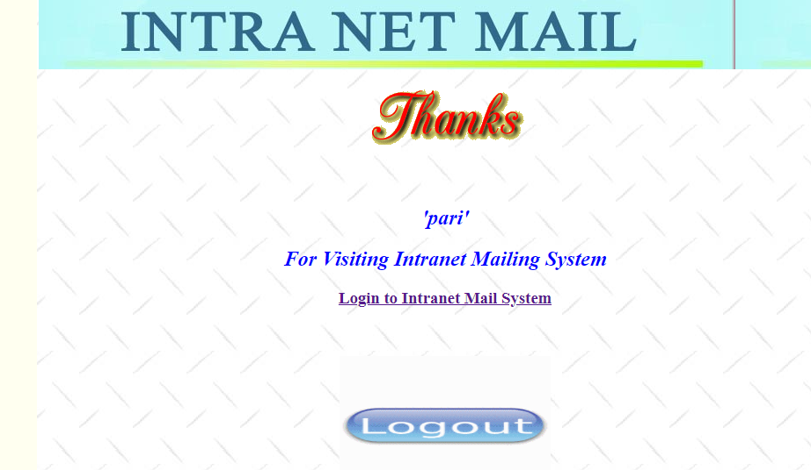

import java.io.IOException;

import javax.servlet.*;

import javax.servlet.http.*;

public class Serv_Logout extends HttpServlet

{

public Serv_Logout()

{

}

public void service(HttpServletRequest httpservletrequest, HttpServletResponse httpservletresponse)

throws ServletException, IOException

{

try

{

scon = getServletContext();

HttpSession httpsession = httpservletrequest.getSession(true);

name = httpsession.getValue("name").toString();

httpsession.removeValue("name");

}

catch(Exception exception)

{

exception.printStackTrace();

}

ServletOutputStream servletoutputstream = httpservletresponse.getOutputStream();

servletoutputstream.println("<html><title>Welcome To Intranet Mail System</title>");

servletoutputstream.println("<body bgcolor='Ivory' text=blue><center>");

servletoutputstream.println("<table background='INDTEXTB.JPG' width='70%' height='100%'>");

servletoutputstream.println("<tr><td background='Images/IMS.JPG' width='100%' height='80'></td></td>");

servletoutputstream.println("<tr><td><center><img src='Images/THANKS.GIF'></center></td><tr>");

servletoutputstream.println("<tr><td align='center'><h2><i>'" + name + "'</i></h2>");

servletoutputstream.println("<h2><i>For Visiting Intranet Mailing System</i></h2>");

servletoutputstream.println("<a href='loginsc.jsp' target=_parent><h3>Login to Intranet Mail System</h3></a></td></tr>");

servletoutputstream.println("<tr><td align='center'><img src='Images/logout.gif' width='240' height='160'></td></tr>");

servletoutputstream.println("</table>");

servletoutputstream.println("</body></html>");

}

ServletContext scon;

String name;

}

**5.2.STANDARDIZATION OF THE CODING/CODE EFFICIENCY**

In my project I have used various controls like command buttons, hover buttons and text box and similar other elements from various classes. Standardization of coding is a very good technique which should be followed while coding the project. Standardization of coding has various advantages over non-standard code such as:

* Standard code can be easily understood
* It is easy to debug
* It is easy to modify
* It is easy to upgrade

In this, project, much care has been given to in developing the standard program code. For example, each java class name start with uppercase letter and each method starts with a lowercase letter, but other words of method except first one starts with uppercase letter. All JSP files are stored in a folder named jsp, all bean classes are stored in a folder named beans with in src package. And all the contents of project code files has been stored according to a proper directory structure***.***

Code of the software is said to be efficient, if the complexity of all types is minimum. In the code of the developed software, I have tried to minimize the space and time complexity, so the code is efficient.

The complexities can be minimized in three ranges. They are called as organized simplicity, disorganized complexity and organized complexity.

Organized complexity is methodologically undeveloped in the sense that neither analytical nor statistical methods are adequate for dealing with systems that fit into it.

Computational complexity: -

Computational complexity is a characterization of time and space requirements for solving a problem by a particular algorithm. Either of these requirements is usually expressed in terms of a single that represent the size of the problem.

Although computational complexity has been predominantly studied in terms of the time it takes to perform a computation, the amount of computer memory is required frequently just as important. This requirement is usually called the space requirement. It is expressed in the terms of a space complexity function, analogous to the time complexity function.

Since the modular approach is used to design the software. This approach uses the object oriented design methods. Hence the code is optimized due to the above reason. Because of object oriented programming, the features like modularity and reusability can be achieved in the software.

Reusability means – the programmer modifies the program’s functionality by replacing the old elements or objects with new objects or by simply plugging new objects into the application. General instruction requires no modification because specific implementation details reside with in the object.

**Optimization of coding**

Optimization of code is very important to produce the better quality of software. Without optimization it is very difficult to debug the syntactical and logical errors present in the code. If the code will be optimized then it becomes trouble-free to find out the errors is stipulated time.

Every step has been taken to optimize the coding. The efforts has been made to modularized the whole working of the software by which it will be easy to locate the errors is time saving manner. Any modification in the requirement of users can also be implemented if the code of the software will be optimized.

For the purpose of code optimization the existing code has been re used, rather than doing all the coding from scratch. For example, all the bean classes and java classes are kept in source package and these are imported on the JSP pages whenever required.

**5.3.ERROR HANDALING**

Handling of errors in this project is done by using try and catch statement for the various operations like insertion of data, updation of data etc. Here I am providing the code of different operations with data:

An Exception occurs when a program encounter any unexpected problems. Such as running out of memory or attempting to read from a file that no longer exists or ORACLE connections not found etc. These problems are not necessarily caused by a programming error but they mainly occur because of violation of assumption that we might have made about the execution environment. When a program encounters an exception the default behavior is to throw the exception which generally translates to abruptly, terminating the program after displaying an error message. But this is not a characteristic of a robust application.

The best way is to bindle the exception situations if possible, gracefully recover from them so that program will not terminate abnormally, instead it will show proper error message. This is called “exception handling”.

In the “**Intranet Mail System**” project, try, catch, finally and throw keywords has been used to handle the exception. And also, it has been tried to keep the condition of occurring an error using prper use of condition statements and displaying appropriate error message:

**“try” Block:-**

Place the code that might cause exception in a try block. A typical try block looks like this-

try

{

//Code that may cause exception

}

A “try” block can have another try block inside when an exception occurs at any point rather than executing any further lines of code, the CLR (Common Language Runtime)

Secures for the nearest try block that enclosure this code. The control is then passed to a matching catch block if any and then to the kindly block associated with this try block.

**“catch” Block:-**

There can be no of catch blocks immediately following a try block. Each catch block handles an exception of a particular type. When an exception occurs in a statement placed inside the try block the CLR looks for a mainly block that is capable of handling the type of exception.

**“throw” keyword:**

A throw statement explicitly generates an exception in code. You can throw when a particular path in code results in an anomalous situation.

**“finally” Block**:

The finally block contains the code that always executes whenever or not any exception occurs.

**5.4.PARAMETERS CALLING/PASSING**

Passing parameters from one web page to another is a very common task in Web development. There are many situations in which we need to pass data from one Web page to another. There are many techniques available for this purpose. The most common techniques used for this purpose are url rewriting, hidden form filled, session management, setAttribute() method of HTTP request etc. In this project “Intranet Mail System”**,** parameter passing has been done using using url re-writing, session and setting attribute in request. However, every method of parameter passing its own limitations and scopes. Using url re-writing has disadvantage that it the passing parameters would be shown in the address bar, so it can’t be used for passing sensitive data. Setting request attribute for passing parameter has limitation that parameter will only be available to the requested page and not elsewhere. HttpSession is used when passing parameters specific to the client Session has number of advantages over the url re-writing and also some disadvantages. The comparison of these is described below-

* Session works on server side, while url re-writing work on client side.
* The information or data stored in query string in url re-writing is visible to everyone. But in Session it is hidden and can’t be viewed easily.
* Query String in url re-writing can store only a piece of information but in Session we can store the more and more data.
* The Query String speed never falls as the load increase because it stores a piece of information. But on the other hand Session increase congestion as the loads increase.

**5.5.VALIDATION CHECKS**

For every system, validations play a very important role while accepting the inputs from the users. This is because, the data being input by the user is further used to keep track of the various activities and their accounts.

In the **intranet mail system** the user inputs are validated because that data is then further used for generation of reports, for verification etc.

In this system two languages are used for validation checks.

**Java Script** is used for validating the user inputs for client site verification. Because user have to insert appropriate data in the data fields. Such as if a user inputs the email id in data field they have to input appropriate email id or if a user inputs name then they cant use number in name.

**JSP** is used for validating the user inputs from database because a proper profile id cannot be inserted if the user_profile is already inserted.

The main validations that are done in **intranet mail system** are as follows:

1. All the screens have a similar look and feel. They all have the almost same color combinations in its background. This provides a better user interface to the users.
2. Whenever a page needs to be refreshed, only a required portion needs to be updated, instead of the whole page. This helps in fast refreshing of the page.
3. Whenever a user logs on to the **intranet mail system** through the Login, his/her rights and privileges are checked and then he/she is allowed to work under the permitted rights only.
4. The data entered by the users is validated before the saving or retrieval of the record.
5. The user, except that administrator, is not allowed to message directly to the other user.
6. Password field contains at least 4 character long data, which stored in the database in the encrypted form.
7. If any data entered by users are wrong then it will shows an error message without proceeding any process.
8. Numeric field only contains numbers like age, mobile no , enrollment no, session, experience, day, month, year field. If any user entered alphabets then it will display an error message to acknowledge the user that he/she is given a wrong entry.
9. After logout, you will have to re-sign-in for using your account.
10. Alphabetical field only contains only alphabets like first name, last name. If any user entered number then it will display an error message to acknowledge the user that he/she is given a wrong entry.
11. User can only fill appropriate email_id in email_id field. If any user entered inappropriate form of emil_id then it will display an error message to acknowledge the user that he/she is given a wrong entry.
12. User should have to enter differ profile_id from existing user.

Thus, we have tried to make this system very secured and reliable by putting a number of validation checks in it. The future versions of this software are supposed to have more extended validations checks based on varied client needs.

**Blank Field validation:**

Most of the fields must not be left blank. If user left blank a mandatory field then an alert message will be displayed and user will be prompted to fill it. Those fields are mandatory to fill before processing the data.

**Date Validation:**

The validation on date data type has been specified to be of the format DD/MM/YYYY. Any other format is unacceptable.

**Number field validation**:

The field specified with number as then their data- type will not accept character. For example mobile number always must be numeric.

**Character field validation**:

The field specified with character as then their data- type will not accept numeric. For example- first name always must be character.

**E-mail field validation:**

When user will input his/her e-mail either to login or register, it will be checked that if it is a valid e-mail or not. If not a valid e-mail then, application will show a alert message and prmpt to input again.

**User Authentication:**

When Employee/Customer/Admin logs on to the system to access data from tables and database, the Id, password and proper login type needs to be checked.

**Password change Validation:**

Only authorized users are allowed to change the password and the process requires asking the old password before changing it to the new one.

**6.1. TESTING**

The development of software systems involves a service of production activities where opportunities for injection of human fallibilities are enormous. Errors may begin to occur at the very inception of the process where the objectives may be erroneously or imperfectly specified, as well as later design and development stages. Because of human inability to perform and communicate with perfection, software companies are accompanied by a quality assurance activity.

Testing is to determine errors in a software code. It is crucial element of software quality assurance and represents the ultimate review of specifications, design and coding. The increasing visibility of a software as a system element and the attendant “costs” associated with a software failure are motivating forces for well planned through testing. Usually software development organizations expend between 30 to 40 percent of total project effort on testing. . Our goal is to design a series of test cases that have a high likelihood of finding errors.

To test the software, there are so many testing techniques which provide systematic guidance for designing tests that exercise the internal logic of software components and exercise the input and output domains of the program to uncover errors in program function, behavior and performance.

If testing is conducted successfully, it will uncover errors in the software. As the secondary benefits, testing demonstrates that software functions appear to be working according to specification, that behavioral and performance requirements appear to have been met

Testing Principlesp:-

* All tests should be traceable to customer requirements.
* Tests should be planned long before testing begins.
* Tests should begin with “in the small” and progress toward testing “in the large”
* Exhaustive testing is not possible.
* To be more effective an independent third party should conduct testing.

**6.2. TESTING TECHNIQUES**

Software design is a critical element of software quality assurance and represents the ultimate review of specification, design and code generation. Once source code has been generated, software must be tested to uncover as many as errors as possible before delivery to the customer. Our goal is to design a series of test cases that have a high likelihood of finding errors. To test the software, there are so many testing techniques which provide systematic guidance for designing tests that exercise the internal logic of software components and exercise the input and output domains of the program to uncover errors in program function, behavior and performance.

If testing is conducted successfully, it will uncover errors in the software. As the secondary benefits, testing demonstrates that software functions appear to be working according to specification, that behavioral and performance requirements appear to have been met. The software can be tested by one of the two ways: -

1. Knowing the specified function that a product has been designed to perform, tests can be conducted that demonstrate each function is fully operational while at the same time searching for errors in each function.
2. Knowing the internal working of the product, tests can be conducted to ensure that internal operations are performed according to specifications and all internal components have been adequately exercised.

The first approach is called white – box testing and the second, black – boxtesting.

6.2.1. White Box Testing:-

White box testing is a test case design method that uses the control structural of the procedural design to derive test cases. It is also called glass box testing. Using this method, we can derive test cases that-

* Guarantee that all independent paths within a module have been exercised at least once.
* Exercise all logical decisions on their true and false sides Executes all loops at their boundaries and within their operational bounds.
* Execute all loops at their boundaries and within their operational bounds.
* Exercise internal data structures to ensure their validity.

## **What is White Box Testing?**

The purpose of any security testing method is to ensure the robustness of a system in the face of malicious attacks or regular software failures. White box testing is performed based on the knowledge of how the system is implemented. White box testing includes analyzing data flow, control flow, information flow, coding practices, and exception and error handling within the system, to test the intended and unintended software behavior. White box testing can be performed to validate whether code implementation follows intended design, to validate implemented security functionality, and to uncover exploitable vulnerabilities.

White box testing requires access to the source code. Though white box testing can be performed any time in the life cycle after the code is developed, it is a good practice to perform white box testing during the unit testing phase.

6.2.2 .Black Box Testing:-

Black – box testing focuses on the functional requirements of the software i.e. it enables the software engineer to derive sets of input conditions that will fully exercise all functional requirements for a program. It is also called behavioral testing.

It attempts to find errors in the following areas:

* Incorrect or missing functions
* Interface errors
* Errors in data structures or external database access
* Performance errors
* Initialization errors

This software is developing as a product to be used by many customers, it is impractical to perform formal acceptance tests with each one. So out software product builders will use a process called Alpha and Beta testing to uncover errors that only the end-user seems able to find.

## Advantages and Disadvantages:-

### Advantages of Black Box Testing

* more effective on larger units of code than [glass](http://www.onestoptesting.com/blackbox-testing/advantages-disadvantages.asp) box testing
* tester needs no knowledge of implementation, including specific programming languages
* tester and programmer are independent of each other
* tests are done from a [user's](http://www.onestoptesting.com/blackbox-testing/advantages-disadvantages.asp) point of view
* will help to expose any ambiguities or inconsistencies in the specifications
* test cases can be designed as soon as the specifications are complete

### Disadvantages of Black Box Testing

* only a small number of possible inputs can actually be tested, to test every possible input stream would take nearly forever
* without clear and concise specifications, test cases are hard to design
* there may be unnecessary repetition of test inputs if the tester is not informed of test cases the programmer has already tried
* may leave many program paths untested
* cannot be directed toward specific segments of code which may be very complex (and therefore more error prone)
* most testing related research has been directed toward glass box testing

A. Alpha Testing:-

The Alpha test is conducted at the developer’s site by a customer. The software is used in a natural setting with the developer “ looking over the shoulder” of the user and recording errors and usage problem. Alpha test are conducted in controlled environment.

B. Beta Testing:-

The Beta-test is conducted at one or more customer sites by the end-user of the software.Unlike Alpha testing, the developer is generally not present. Therefore, the Beta-test is a “live” application of the software in an environment that cannot be controlled by the developer. The customer records all problems ( real or imagined ) that are encountered during Beta testing and reports there to the developer at regular intervals. As a result of problems reported during Beta-tests, software engineers make modifications and then prepare for release of the software product to the entire customer base.

In this project we will performed incremental testing in which components and subsystem of the system are tested separately before integrating them to form the system from system testing.

**6.3.TESTING STRATEGIES**

Designing effective test cases is important but so is the strategy we use to execute them. A strategy for software test case design methods that result in the successful construction of software. The strategy provides a road map that describes the steps to be conducted as a part of testing.

There are a number of testing strategies, which have the following generic characteristics: -

* Testing begins at the component level and works “outward” toward the integration of the entire computer–based system.
* Different testing techniques are approximate at different points in time.
* Testing is conducted by the developer of the software and (for large projects) an independent test group.
* Testing and debugging are different activities, but debugging must be accommodated in any testing strategy.

System engineering

Requirements

System testing

Validation testing

Integration testing

Testing Strategy

Initially, system engineering defines the role of software and leads to software requirement analysis where the information domain, function, behavior, performance, constraints and validation criteria for software are established. Moving inward along the spiral, we come to the design and finally to coding. There are a number of testing strategies, which are given below: -

Unit testing:-

In the unit testing interfaces, local data structures, boundary conditions, independent paths, error-handling paths are tested. Test cases should be design to uncover errors due to erroneous computations, incorrect comparisons, or improper control flow. For this purpose basis path and loop testing is done. After source level code has been developed, reviewed and verified for correspondence to component level design, unit test case design begins. In unit test application ‘drivers’ are developed which are programs, accept test case data, passes such data to the component to be tested and prints relevant results. ‘Stubs’ are also developed which serve to replace modules, that are subordinate the component to be tested.

## **Six Rules of Unit Testing:-**

1. Write the test first
2. Never write a test that succeeds the first time
3. Start with the null case, or something that doesn't work
4. Don't be afraid of doing something trivial to make the test work
5. Loose coupling and testability go hand in hand
6. Use mock objects

Limitations of unit testing:-

Testing, in general, cannot be expected to catch every error in the program. The same is true for unit testing. By definition, it only tests the functionality of the units themselves. Therefore, it may not catch integration errors, performance problems, or other system-wide issues. Unit testing is more effective if it is used in conjunction with other software testing activities.

Like all forms of software testing, unit tests can only show the presence of errors; it cannot show the absence of errors.

Software testing is a combinatorial problem. For example, every boolean decision statement requires at least two tests: one with an outcome of "true" and one with an outcome of "false". As a result, for every line of code written, programmers often need 3 to 5 lines of test code. Therefore, it is unrealistic to test all possible input combinations for any non-trivial piece of software without an automated characterization test generation tool such as JUnit Factory used with Java code or many of the tools listed in List of unit testing frameworks.

To obtain the intended benefits from unit testing, a rigorous sense of discipline is needed throughout the software development process. It is essential to keep careful records, not only of the tests that have been performed, but also of all changes that have been made to the source code of this or any other unit in the software. Use of a version control system is essential. If a later version of the unit fails a particular test that it had previously passed, the version-control software can provide a list of the source code changes (if any) that have been applied to the unit since that time.

It is also essential to implement a sustainable process for ensuring that test case failures are reviewed daily and addressed immediately. If such a process is not implemented and ingrained into the team's workflow, the application will evolve out of sync with the unit test suite—- increasing false positives and reducing the effectiveness of the test suite.

Integration testing:-

Integration testing is systematic technique for constructing the program structure while at the same time conducting the tests to uncover errors associated with interfacing. The objective is to take unit tested components and build a program structure that has been dictated by design. There are two types of integration – Bottom up integration and Top down integration. Regression and smoke testing are done in integration testing strategy.

Validation testing:-

Next step is the validation testing where requirements established as part of software requirements analysis are validated against the software that has been constructed. At the culmination of integration testing, software is completely assembled as a package, interfacing errors has been uncovered and corrected, and a final series of software tests i.e. validation testing begins. Validation succeeds when software functions in a manner that can be reasonably expected by the customer.

Software validations can be achieved through a series of black-box tests that demonstrate conformity with requirements. Configuration review, alpha testing and beta testing techniques are conducted to enable the customer to validate all requirements. Acceptance tests are conducted by the end-users over a period of weeks or months.

System testing:-

Finally, we arrive at system testing where the software and other system elements are tested as a whole. System testing verifies that all elements mesh properly and that overall system function / performance is achieved. Ultimately software is incorporated with other system elements and a series of system integration and validation tests are conducted.

**6 .4. TEST CASES**

**T E S T C A S E -1**

TEST NO. : 1

TEST TYPE : UNIT TESTING

INPUT : PASSWORD

OBJECTIVE : CHECKING PASSWORD SECURITY

EXPECTED OUTPUT : ACCESS TO AUTHORIZED USERS ONLY

ACTUAL OUTPUT : PASSWORD SECURITY SUCCESSFUL

RESULT : ACCESS TO ONLY AUTHORIZED USERS

**T E S T C A S E -2**

TEST NO. : 2

TEST TYPE : UNIT TESTING

INPUT : DATA ENTRY TO REGISTER FORM

OBJECTIVE : TO STORE VALID DATA IN THE TABLE

EXPECTED OUTPUT : SUCCESSFUL DATA STORAGE

ACTUAL OUTPUT : SUCCESSFUL DATA STORAGE

RESULT : DATA STORED

**TE S T C A S E : 3**

TEST NO. : 3

TEST TYPE : UNIT TESTING

INPUT : DATA ENTRY TO VARIFICATION OF USER TYPE

OBJECTIVE : TO OPEN USER OR ADMIN PAGE

EXPECTED OUTPUT : SUCCESSFUL OPEN USER HOME PAGE

ACTUAL OUTPUT : SUCCESSFUL OPEN USER HOME PAGE

RESULT : ACKNOWLEGMENT

**T E S T C A S E -4**

TEST NO. : 4

TEST TYPE : UNIT TESTING

INPUT : DATA ENTRY MAIL DETAILS

OBJECTIVE : FOR MAIL

EXPECTED OUTPUT : SUCCESSFUL MAIL INSERT IN DATABASE

ACTUAL OUTPUT : SUCCESSFUL MAIL INSERT IN DATABASE

RESULT : ACKNOWLEGMENT

**T E S T C A S E -5**

TEST NO. : 5

TEST TYPE : UNIT TESTING

INPUT : MAIL CATEGORY

OBJECTIVE : TO SAVE DATA INTO THE DATABASE

EXPECTED OUTPUT : SAVE DETAILS

ACTUAL OUTPUT : SAVE DETAILS

RESULT : OK

**TEST CASE – 6**

TEST NO : 6

TEST TYPE : UNIT TESTING

INPUT : SELECT MESSAGE

OBJECTIVE : FOR CHAT

EXPECTED OUTPUT : BETTER MATCHING PROJECT

ACTUAL OUTPUT : BETTER MATCHING PROJECT

RESULT : OK

**6 .5. DEBUGGING AND CODE IMPROVEMENT**

Since the modular approach is used to design the software. This approach uses the object oriented design methods. Hence the code is improved due to the above reason. Because of object oriented programming, the features like modularity and reusability can be achieved in the software.

.

In my project I have used various controls like command buttons, text box and similar other elements from various class.

The process of testing gives symptoms, and a program’s failure is a clear symptom of the presence of the error. After getting a symptom, we begin an investigation to localize the error, that is to find out which module or interface is causing it. Then that section of the code is to be studied to determine the cause of the problem. This process is called ‘Debugging’. Hence, debugging is the activity of locating and correcting errors.

The following errors has been debugged during the creation of the project-

|  |  |  |  |
| --- | --- | --- | --- |
| ***S.No.*** | ***Bug Description*** | ***Cause of Bug*** | ***Time required to remove it*** |
| ***1.*** | ***Update error*** | ***Database Connectivity problem*** | ***10 Minutes*** |
| ***2*** | ***Retrieve error*** | ***Sql error*** | ***20 minute*** |
| ***3.*** | ***Database Insert Error*** | ***Data Type not match*** | ***20 Minutes*** |
| ***4.*** | ***Record Not Found*** | ***DB error*** | ***10 Minutes*** |
| ***5.*** | ***Duplicate entry error*** | ***It occurred because another record exist with same id*** | ***5 Minutes*** |
| ***6.*** | ***Null pointer exception*** | ***A method of query class getting null as input*** | ***15 Minutes*** |
| ***7.*** | ***No such method error*** | ***It occurred because, a non- existent method was called from jsp page*** | ***5 minutes*** |

**Code improvement:-**

After debugging, it has been that there is some problem in coding and hence to rectify the error occurred during the testing the improvement in the code is necessary. Following improvement has been done in coding after testing:-

* Error prone code has been removed
* All the missing classes has been properly imported
* Automatic table creation code has been added
* More accurate sql query has been written

**7 . SYSTEM SECURITY MEASURES**

The purpose of security is to protect the organization valuable resources, such as information, hardware, and software. Through the selection and application of appropriate safeguards, security helps the organization's mission by protecting its physical and financial resources, reputation, legal position, and other tangible and intangible assets. Unfortunately, security is sometimes viewed as thwarting the mission of the organization by imposing poorly selected bothersome rules and procedures on customer, admin and systems. On the contrary, well-chosen security rules and procedures do not exist for their own sake they are put in place to protect important assets and thereby support the overall organizational mission. Security is an integral element of sound management. Information and computer systems are often critical assets that support the mission of an organization. Protecting them can be as critical as protecting other organizational resources, such as money, physical assets. Ultimately, organization managers have to decide what the level of risk they are willing to accept, taking into account the cost of security controls.

Electronic means of security are essential to protect confidential data recorded on electronic media.

The two major methods of electronic security are system security and application security. The idea of system security is to prevent unauthorized access to the system as a whole. For our purposes, systems are Personal Computer (PC's), Local Area Networks (LAN's), and centralized Data Centers. LAN's and Data Centers can require a pre-established account with password protection before allowing generalized access. PC's can be password protected or have their keyboards locked. Where as Application Security Measures needs the system security is a necessary barrier to unauthorized access, but it is not sufficient. Once a system barrier is breached, all program data within the system would be available unless application security measures are in place. Application security measures essentially repeat the systems security measures for each existing application. Applications have different passwords to limit security breaches. Passwords should be known only to the individual and if written down, should be physically secured, not taped to the side of the computer for ease of use. Security should be periodically reassessed. Security can enhance the access and flow of data and information by providing more accurate and reliable information and greater availability of systems. Security can also increase the privacy afforded to an individual or help achieve other goals set by society.

#### User:-

Each user is given a control number. This is operative at OS level. The DBA (Super user) is responsible for allocating the control number.

###### DATA BASE :-

Each database has a password. The password is given by DBA and access is restricted to DBA only. The user access to database is restricted and is only through application programmers.

###### CONTROLS :-

Accessibility of the some of the control tasks depends on the level of the particular user. Depending on the level of the user authorization limit / level which will be predefined, and accessibility limit will be fixed. Programmers will control this.

### SECURITY:-

Relational databases also have excellent security. In most database programs there is a special database that contains access permissions for users and databases. This allows a database administrator the ability to tune permissions to needs. The basic set of permissions SQL include the following:

* Select Privilege - Ability to search data in tables
* Insert Privilege - Ability to add data in tables
* Update Privilege - Ability to modify data in tables
* Delete Privilege - Ability to delete data in tables
* Index Privilege - Ability to index tables
* Alter Privilege - Ability to alter tables
* Create Privilege - Ability to create databases
* Drop Privilege - Ability to delete databases

**7 .1.DATABASE SECURITY**

I have used Oracle as the back end. Therefore the security mechanisms provided by Oracle is also available to this system. Now here I will discuss the security features of Oracle. Oracle includes security features that control the accessing and using of a database. For example, security mechanisms in Oracle:

* Prevent unauthorized database access
* Prevent unauthorized access to schema object
* Audit user actions

Associated with each database user is a schema by the same name. By default, each database user creates and has access to all objects in the corresponding schema.Database security can be classified into two categories: system security and data security.

System security includes mechanisms that control the access and use of the database at the system level. For example, system security includes:

* Valid user name/password combinations
* The amount of disk space available to a user’s schema objects
* The resource limits for a user

System security mechanisms check whether a user is authorized to connect to the database, whether database auditing is active, and the system operations that a user has been permitted to perform.

The Oracle database provides discretionary access control, which is a means of restricting access to information based on privileges. The appropriate privilege must be assigned t a user in order for that user to access a schema object. Appropriately privileged users can grant other users privileges at their discretion.

Oracle manages database security using several different facilities:

* Authentication to validate the identify of the entities using your networks, databases, and applications.
* Authorization processes to limit access and actions, limits that are linked to user’s identities and roles.
* Access restrictions on objects, like tables or rows.
* Security policies, and
* Database auditing

**7 .2.CREATION OF USER PROFILE S AND ACESS RIGHTS**

I have classified the users of this system into three categories :

* Registered users
* Admin

Registered users are the user of the site who have registered with the site. Here they have provided their personnel information to do e-commerce with the site. They are able to buy the various items which the visitors are not able to do.

Admin is the administrator of the whole site. He is responsible for all the database related work. Admin provides the inventory information. He can also add or modify albums and items. He also got the capability of deleting any existing registered user.

To differentiate between these different kinds of user I have used the authentication based mechanism.

AUTHENTICATION MECHANISM:-

The primary goal of authentication is to allow access to legitimate system users and to deny access to unauthorized parties. The two primary measures of authentication effectiveness are-

1. The false acceptance rate, that is, the percentage of illegitimate users erroneously admitted, and
2. The false rejection ratio, that is, the percentage of legitimate users who are denied access due to failure of the authentication mechanism.

Obviously, the objective is to minimize both the false acceptance and the false rejection ratio. One–way authentication is usually based on-

* + Possession of the secret (password)
  + Possession of an artifact
  + Unique physiological or behavioral characteristics of the user

But for my software, I have chosen the authentication based on password. The password is the most common authentication mechanism based on sharing of the secret. In a password based system each user has a password, which may initially be assigned by the system or an administrator. Many systems allow users to subsequently change their password. The system stores all user passwords and uses them to authenticate the users. When logging in, the system requests and the user supply the presumably secret, user specific password. Password require no special hardware and easy to implement

FIREWALL SECURITY SYSTEM:-

In the implementation of the E-Music(Online Music Website) on the web server we need proper security. A web-based application when apply at the web server then it should be secure by the firewall. The firewall security system is applied on the server side authentication for securing the unauthorized access. Internet managers are used to the idea that a proxy server, a specialized HTTP server typically running on a Firewall machine, would be enough to provide secure access from Internet connections coming through the firewall into the protected network.

A firewall protects our network from un trusted networks. On one side we have a public network, without any kind of control over what is being done, how or where. On the other side our production network that must be protected against any damaging action. The problem is that when company is connected to the Internet without proper security measurements in place, we become exposed to attacks from other servers on the Internet. Not only does our corporate network become vulnerable to unauthorized access, but also do all other servers in our corporate network. This time firewall screens and filters all connections coming from the Internet to the protected (corporate) network, and vice versa, through a single, concentrated security checkpoint.

A firewall makes sure that anyone cannot reach the Internet from the internal network, nor vice versa. A firewall greatly improves network security and reduces risks to servers on our network by filtering inherently insecure services.

A firewall is actually less expensive for organization in that all (or most) modified software and additional security software can be located on the firewall system than if distributed on each server or machine

TCP/IP FILTERING:-

A large Number of Network ports are left open by default by the server, unless specified otherwise. Fortunately, as we know which particular ports HTTP, FTP, etc. is in use, we can shut down all, even if it’s already behind a firewall or proxy server. Still in the Advance TCP/IP setting dialog box, select the Options tab then properties for TCP/IP filtering.

* Check the Enable TCP/IP Filtering checkbox, if it isn’t already checked.
* Under TCP ports, we should only add ports we know are being used, for example, port 21 for FTP, port 80 for HTTP, port 443 for SSL, and port 25 for SMTP. There may of course be others which we should add accordingly.
* We should allow no UDP ports unless needed.

**1. User Screens**

**Home Page of User****

**Figure : Home page for user**

**User Registration Page**



**User Login Page**



**After login Page**



**Inbox page:-**



**compose mail:-**

**

**option page:-**

**

**chat room page:-**



**logout page:-**



**REPORTS**

In the **Intranet Mail System** there are a number of formats in which the reports can be generated. The names and grabs of some of the reports that can be generated are as follows -

* Mail detail categry wise
* Search category wise
* Compose detail
* Process detail
* Attachment detail
* Feedback detail
* Avilabelety detail

The project titled as “Intranet Mail System” is a web based application. The application is built to perform and deliver the best in terms of:

* Ease of operations
* Completeness, as judged by the employee(the organization)
* Efficiently delivering – “what is required”?
* Adaptability to required changes and updating

This software has been developed with scalability in mind. Additional modules can be easily added when necessary. The software is developed with modular approach. All modules in the system have been tested with valid data and invalid data and everything work successfully. Thus the system has fulfilled all the objectives identified and is able to replace the existing system.

The project has been completed successfully with the maximum satisfaction of the organization. The constraints are met and overcome successfully. The system is designed as like it was decided in the design phase. The project gives good idea on developing a full-fledged application satisfying the user requirements.

The system is very flexible and versatile. This software has a user-friendly screen that enables the user to use without any inconvenience. Validation checks induced have greatly reduced errors. Provisions have been made to upgrade the software. The application has been tested with live data and has provided a successful result. Hence the software has proved to work efficiently.

The project has been completed successfully with the maximum satisfaction of the organization. The constraints are met and overcome successfully. The system is designed as like it was decided in the design phase. The project gives good idea on developing a full-fledged application satisfying the user requirements.

The system is very flexible and versatile. This software has a user-friendly screen that enables the user to use without any inconvenience. Validation checks induced have greatly reduced errors. Provisions have been made to upgrade the software. The application has been tested with live data and has provided a successful result. Hence the software has proved to work efficiently

**FUTURE SCOPE**

The future scope of this project, **Intranet mail system** is very wide. There are many additional features, which are planned to be incorporated during the future enhancements of this project.

Although all the main objectives according to SRS document have been achieved but still there is room for enhancement.

* + - Providing the **SMS alerts** facility to users to remove the dependency on email account (web).
    - As the project is flexible, so in future ‘DOCUMENT ATTACHMENT’ can be added in the project.
* This software can be easily upgraded in the future. And also include many more features for existing system.
* It is connected to the network for easy retrival of data and many more location or many districts or cities in different states.
* All the information can be easily accessed by the employee like their details, mails, departments. It can be modified and the other details can be easily provided to customer.
* If anyone wants to combine all the departments of organization through internet then he can easily do this with the help of this technology called java.

**BIBLIOGRAPHY**

*Books:*

* ***Java-2 Complete Reference - by Patrick Naughton***
* ***Java Servlet Programming - by O'Reilly***
* ***Pure JavaScript - by Jason Gilliam, Charlton*** Try, R .Allen Wyke
* ***HTML Complete - BPB publications.***
* ***Java Server Programming - by Apress publication.***

*SITES:*

* [***http://www.sun.com***](http://www.sun.com)
* ***http://***[***www.coreservlets.com***](http://www.coreservlets.com)
* [***http://www.serverside.com***](http://www.serverside.com)
* [***http://www.w3schools.com***](http://www.w3schools.com)
* [***http://www.google.com***](http://www.google.com)
* [***http://www.webopedia.com***](http://www.webopedia.com)
* [***http://www.ddj.com***](http://www.ddj.com)

**GLOSSARY**

**IMS : Intranet mail system**

**EERD : Enhanced ER Diagram**

**DFD : Data Flow Diagram**